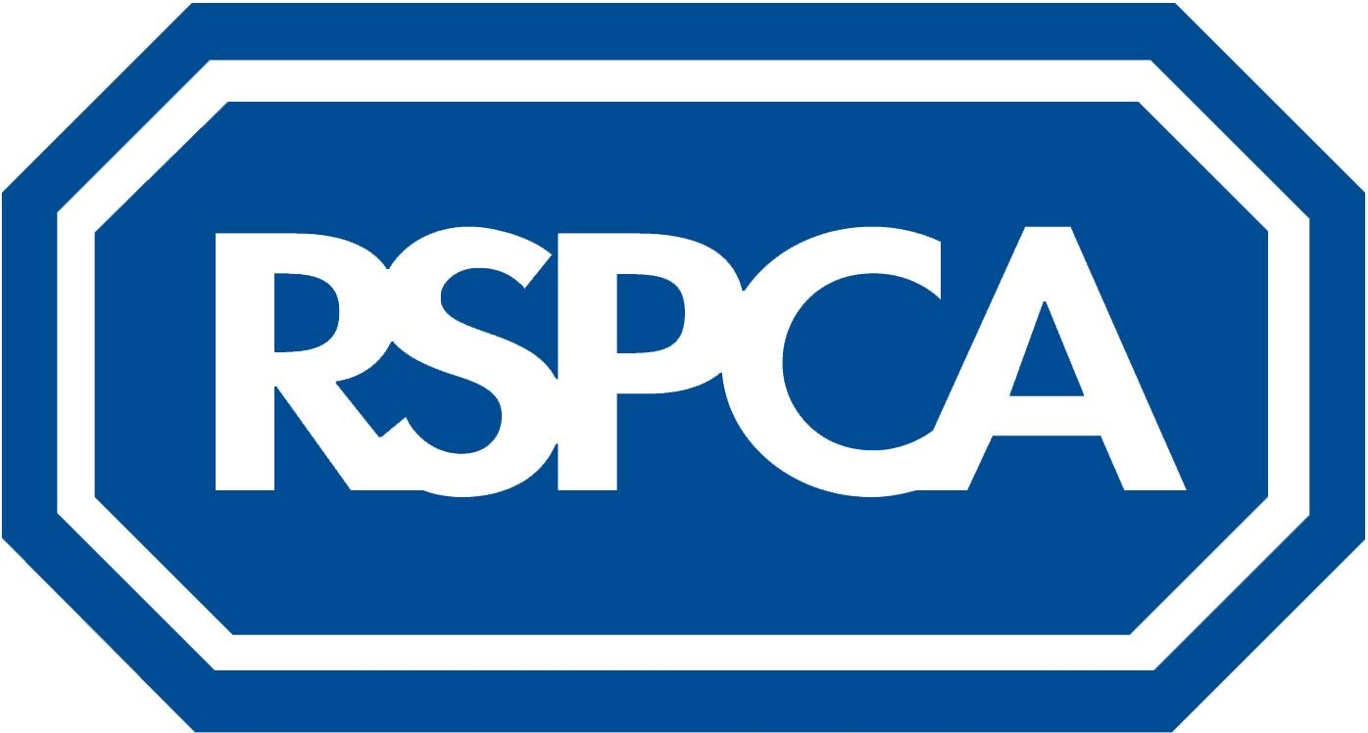

**HR National Job Advert Template**

**Job title**: Veterinary Surgeon (part time, fixed term contract)

**Location:** Merthyr Tydfil Clinic

**Salary**: Circa. £37,700 per annum

**Hours:** Part time (7 to 17.5 hours per week)

**Closing date:** 10:00 Friday 13th May 2022

Do you consider yourself a strong advocate for animal welfare? If so, a career with the RSPCA may be just what you are looking for!

We have an exciting opportunity for a part time Veterinary Surgeon to join the Clinic in Merthyr Tydfil on a fixed term contract for 12 months to share responsibility with our existing in-house Veterinary Surgeon.

The Merthyr Tydfil Animal Clinic at The Willows in Abercanaid, Merthyr Tydfil, was opened in October 2005. We provide an extensive range of veterinary services, including consultations, operations, dentistry, neutering and microchipping. Our team of staff provide expert nursing and veterinary care.

We provide a veterinary service for sick and injured animals that have been rescued by RSPCA inspectors, and at a low cost for pets belonging to people on low incomes or certain benefits who live in the surrounding community.

As a Veterinary Surgeon you’ll be assessing and treating animals brought into the Clinic and performing consultations and administering medical treatments according to RCVS standards.

You’ll be working shifts between 08:30 - 16:30 with no out of hours or weekend work. We can be flexible with the working hours and can offer between 7 to 17:5 hours per week, please contact us if you would like to discuss further. There is also the possibility of working occasionally at our Newport Animal Centre.

**What you’ll be doing:**

* Performing consultations and treatment on animals within our care
* Undertaking a wide variety of surgical procedures for the animals in our care including high volume/quality cat neutering
* Providing veterinary advice to public clients and RSPCA colleagues
* Providing veterinary opinion and support for welfare prosecution cases (training will be provided)
* Demonstrating competence across veterinary disciplines, including;
  + Soft tissue surgery
  + Ophthalmology
  + Clinical pathology
  + Shelter medicine
* Training Centre staff in standard procedures and protocols
* Implementing RSPCA policies in regards to the re-homability of stray animals including decision making on individual cases

**You’ll have:**

* Membership of the Royal College of Veterinary Surgeons
* Previous clinical experience
* The ability to perform routine consultations in 10 minutes or less and routine surgeries quickly and safely
* The ability to be sensitive to the financial constraints of owners in the treatment of their animals

**What’s in it for you:**

You’ll have an opportunity to work for the largest animal welfare charity in England and Wales.

We value and recognise our employees’ contribution and are proud to offer an extensive benefits package that includes:

17.5 hours (35 hours FTE) standard working week, 12.5 days (25 days FTE) annual leave plus bank holidays; a generous pension scheme with associated life assurance and group income protection scheme; access to private healthcare scheme; support for professional development after qualifying period and access to our employee assistance programme. We also offer free parking on site.

**How to apply:**

Please send your CV and cover note to [ResourcingTeam@rspca.org.uk](mailto:ResourcingTeam@rspca.org.uk) quoting reference **VS6154** by the closing date on Friday 13th May 2022.

Early applications are encouraged as we reserve the right to close the advert early once sufficient submissions are received.

All online information and documents are available in alternative formats, including Braille and large font, upon request from the Resourcing team.

*We strongly believe in being an innovative, diverse, and inclusive organisation and recognise that diversity in all of our people will help achieve that purpose and our mission more effectively. We strongly encourage and seek applications from a wide diversity of candidates and in particular welcome applications from minority ethnic, black, and candidates with disabilities, who are currently under-represented at the RSPCA.*

*Ending cruelty, promoting kindness and alleviating suffering to animals.*