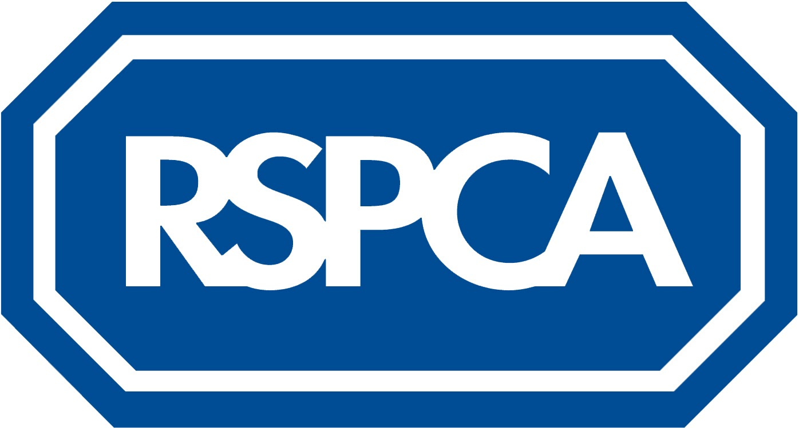

**HR National Job Advert Template**

**Job title**: Veterinary Nurse (part time, fixed term contract)

**Location:** Merthyr Tydfil Clinic

**Salary**: Circa. £21,300 per annum (pro-rata for part time)

**Hours:** Part time (10.5 hours)

**Closing date:** 10:00 Wednesday 8th June 2022

Do you consider yourself a strong advocate for animal welfare? If so, a career with the RSPCA may be just what you are looking for!

We have an exciting opportunity for a part time Veterinary Nurse to join the Clinic in Merthyr Tydfil. You’ll be joining our veterinary team helping with nursing, anaesthetics and reception duties.

The Merthyr Tydfil Animal Clinic at The Willows in Abercanaid, Merthyr Tydfil, was opened in October 2005. We provide an extensive range of veterinary services, including consultations, operations, dentistry, neutering and microchipping. Our team of staff provide expert nursing and veterinary care.

We provide a veterinary service for sick and injured animals that have been rescued by RSPCA inspectors, and at a low cost for pets belonging to people on low incomes or certain benefits who live in the surrounding community.

As a Veterinary Nurse you’ll be working alongside two other Veterinary Nurses in administering treatments and triaging patients for the Veterinary Surgeons.

**What you’ll be doing as a Veterinary Nurse:**

* Direct medical and surgical patient care, utilising your nursing capabilities in both medical and surgical roles
* Triage patients for the attention of the veterinary surgeon
* Maintain up to date and accurate clinical records
* Dispense drugs in accordance with professional guidelines clinic rules
* Cleaning and maintenance of all surgical areas, wards, theatres and x ray rooms
* Cleaning and basic maintenance of veterinary equipment and machinery (eg radiography, endoscopy and dental) and sterilisation of surgical instruments
* Check machinery and other equipment as part of pre-ops and provide assistance to the vet as necessary during operations
* Ensure that all clients of the clinic receive accurate itemised bills at the time of treatment and keep full records of these
* Undertake continuing professional and personal development associated with the role

**You’ll have:**

* Either a Level 3 Diploma in Veterinary Nursing or a Degree in Veterinary Nursing
* Registration with the RCVS
* Good communication skills
* A professional approach to veterinary nursing and clinical care
* Self motivation and be able to manage your own time
* The ability to demonstrate teamwork with veterinary animal centre and Inspectorate colleagues

**What’s in it for you:**

You’ll have an opportunity to work for the largest animal welfare charity in England and Wales.

We value and recognise our employees’ contribution and are proud to offer an extensive benefits package that includes:

10.5 hours which equates to 1.5 days per week (35 hours FTE) standard working week, 8 (25 days FTC) annual leave plus bank holidays; a generous pension scheme with associated life assurance and group income protection scheme; access to private healthcare scheme; support for professional development after qualifying period and access to our employee assistance programme. We also offer free parking on site.

**How to apply:**

Please send your CV and cover letter to [ResourcingTeam@rspca.org.uk](mailto:ResourcingTeam@rspca.org.uk) quoting reference **VN6247** by the closing date on Wednesday 8th June 2022.

Early applications are encouraged as we reserve the right to close the advert early once sufficient submissions are received.

All online information and documents are available in alternative formats, including Braille and large font, upon request from the Resourcing team.

*We strongly believe in being an innovative, diverse, and inclusive organisation and recognise that diversity in all of our people will help achieve that purpose and our mission more effectively. We strongly encourage and seek applications from a wide diversity of candidates and in particular welcome applications from minority ethnic, black, and candidates with disabilities, who are currently under-represented at the RSPCA.*

*Ending cruelty, promoting kindness and alleviating suffering to animals.*