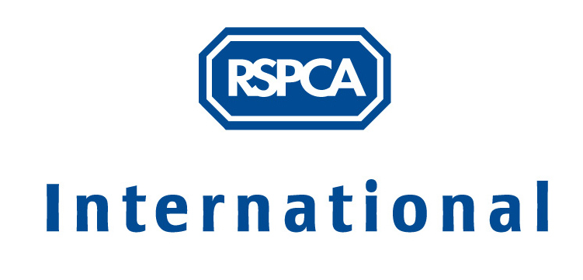

Risk Assessment

MINIMISING RISK

There are many hazards faced in any workplace, and working with animals can bring additional ones. It is always important to assess the risks involved in an organisation’s work, and take action to minimise any harm that could result. For an animal welfare organisation, which witnesses pain and suffering on a regular basis and often struggles with limited resources, it is vital to make sure no reasonably avoidable harm is caused either to the animals in your care or to those that care for them. Carrying out a risk assessment is a recommended tool to help in doing this.

What is a risk assessment?

A risk assessment is a structured process usually undertaken to carefully examine what in your work could cause harm to people, so that you can assess what precautions need to be taken to prevent such harm. It can also be extended to cover potential harm to animals, the environment or an organisation as a whole. For people and animals, potential harm would typically be disease, injury, illness, or psychological damage. For organisations, the potential harm could be financial difficulties or disrupted, reduced or poor services, or closure.

Why is a risk assessment necessary?

In some countries there are specific legal duties on organisations to minimise harm to employees, volunteers and other people visiting their premises, such as contractors or members of the public. So the law in your country may require a risk assessment to be carried out. Even where this is not the case, it is usually advisable for some such assessment to be conducted to make sure no one gets hurt or becomes ill and to minimise other losses that could result from any harm occurring. Accidents and ill health can ruin lives and affect your organisation too if work capacity or income is lost, buildings and equipment damaged, insurance costs increased, or you have to go to court.

What is involved?

The main steps to be taken in carrying out a risk assessment are:

- Identify any hazards, in the physical conditions/environment or in the activities carried out there, which could reasonably be expected to cause significant harm. Look at each of the main types of hazard (see table [below]) and ask what is being undertaken in your organisation that might fall within these categories.
- Identify the severity of harm that would occur if the hazards were realised. These will range from trivial, minor injury, major injury to one or more persons, death to one person, or multiple deaths.
- Identify who might be affected e.g. employees, visitors, volunteers, children, pregnant workers, contractors, animals
- Evaluate the likely risk (high, medium, low) of each hazard being realised and someone being harmed by it, and decide whether existing precautions are adequate or more should be done so that the risk is small. If something needs to be done, consider first if you can get rid of the hazard altogether; if not, then how you can control the risk so harm is unlikely.
- Record the results of the assessment. This is helpful for your future use, or if you become involved in any legal liability action. Results are often presented in a table format with the following headings – hazard, people affected, control measures, level of risk, further action. It may also include the nature of potential harm.
- Implement the identified necessary controls. You should prioritise those risks that affect large numbers of people or animals, and/or could result in serious harm.
- Monitor your assessment and review it when necessary, e.g. if there is any significant change such as new equipment, new job involving significant new hazards, change in location, change in type of species being cared for, etc which makes the first assessment unsound. Risk assessments should also be reviewed following an accident, incident or near miss, and according to your organisational policy, usually annually.

The assessment should consider both normal performance and when tasks will not be performed according to plan, such as in foreseeable emergency situations. It should also consider necessary precautions for changes in individual’s medical circumstances e.g. pregnancy or medication.

Common precautions will include accident & emergency procedures, control of hazardous substances (access, storage, labelling, instructions for use, protective clothing, hygiene requirements, restrictions on smoking and food preparation and consumption, spillage, disposal) general procedures including reporting of accidents, appropriate dress, suitable equipment, training.

Main Types of Hazard
- Chemical - substances being used or exposed to during a task. Consider both hazardous substances (those that are toxic, corrosive, flammable, harmful or irritant, such as medicines, fumigants, anaesthetics, disinfectants) and non-hazardous products (those that are reasonably safe but can be harmful if handled improperly).
- Biological – direct contact with biological hazards or exposure to them within the environment where a task is being carried out, e.g. bodily fluids, clinical waste, carcass disposal.
- Physical - physical activities that will be performed e.g. lifting heavy objects, use of ladders, driving.
- Environmental – exposure to environmental hazards while carrying out tasks e.g. dust, vapours, fumes, noise, hot/cold extreme weather conditions, fire
- Facilities & machinery – insecure, inappropriate or inadequately maintained premises, buildings and equipment e.g. electrical appliances and cables, computer VDUs, lighting, ventilation, floors, stairs, equipment, vehicles
- Animals – direct and indirect contact with live or dead animals e.g. cuts and bites from handling, zoonotic diseases, including specifically during pregnancy
- Competency – minimum levels of training and /or experience required to carry out a task safely
- Human error – identifying likely human error during the performance of tasks that create higher risks, why they occur, how to recognise when they may occur and how to prevent them re-occurring are essential parts of the risk assessment. The vast majority of accidents are caused by unsafe acts carried out by people, rather than unsafe conditions such as defective equipment or a hazardous environment. Unsafe acts include unauthorised working, not following rules or training, not using required protective clothing or equipment provided, equipment left in a dangerous state, poor maintenance, prohibited behaviour such as drinking or smoking in restricted areas, etc. If human error is foreseeable, controls must be put in place to prevent it, e.g. training, checklists, design controls, supervision.
- Organisational – working within organisations involves interpersonal interactions and expectations that can cause harm e.g. internal communication, organisational culture, management style, work overload, unclear expectations of performance, bullying & harassment, undefined limits to operational activities
- Sector specific stresses – for animal welfare organisations this includes traumatic events such as violence, witnessing cruelty, routine euthanasia, absence of animal protection legislation or enforcement, abuse from members of public, lone working, insufficient resources

The RSPCA produces the following publications on Health & Safety issues:

- Health & Safety at Work – booklet
- Control of Substances Hazardous to Health – booklet
- Protection of Hearing at Work – leaflet
- Asthma and Respiratory Sensitisers at work – leaflet
- Stress and Time Management Manual – booklet
- The Prevention and Management of Work Related Stress in the RSPCA Inspectorate and Animal Collection Officer Service – report
- Health & Safety Working Instructions for Managers

If you would like a copy of any of these, please send you request to: International Department, External Affairs, RSPCA, Wilberforce Way, Southwater, Horsham, RH13 9RS, United Kingdom.

