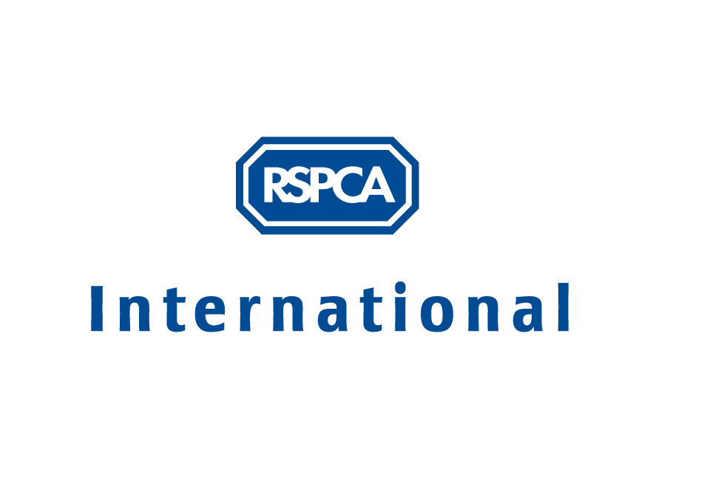

Mission Statement, Aims and Objectives

THE CHARITY SECTOR ROLE

The existence of charitable organisations working to prevent cruelty and promote kindness to animals is of significant importance, not only in providing services to deal with everyday animal welfare problems, but also in educating future generations, and informing public debate and political decision-making on animal welfare legislation, policies and practice. It is important such organisations are built on strong foundations and operate in a sustainable way, to ensure ongoing maximum impact for animal welfare.

The priority for a private sector organisation is to make a profit. For a public sector organisation it is to provide a service. For a charity it is to enhance services already provided and fill gaps where there are no services. It is therefore essential to clearly identify the particular service you will provide, who your beneficiaries are and how the service responds to a problem or need that is not being addressed. In order to ensure your organisation can continue to exist, the need or problem should be one that potential funders also want addressed.

Example: In responding to the welfare problems of a stray dog population, the “gap” may be in lobbying for improvements to a local authority shelter, or providing a re-homing service, rather than necessarily building another shelter and taking on the local authority’s responsibility - unless they cannot be persuaded to provide a humane service. The beneficiaries of the lobbying and re-homing would not only be the dogs who would benefit from improved conditions and new homes; but also the new dog owners, the general public and the local authority.

VISION / MISSION STATEMENT

A mission statement states the purpose and values of your organisation, summarising in one sentence its aims and objectives. It broadly states why your organisation exists and your main beneficiaries; and shows the nature and quality of what your organisation can provide in a way that is better or different from other similar services. The mission statement thus sets the direction for the organisation and its strategic development and management. By stating the values that are the shared beliefs of your members, it defines criteria to decide between options to achieve the objectives.

Example: “The mission of [organisation name] is to alleviate the suffering of companion animals in [our country/region/town] by providing services to enhance the welfare of abandoned companion animals and educating the public on companion animal suffering and needs”.

Developing a mission statement: You can create this directly from your vision of the organisation – individually write down 1 or 2 sentences describing your vision/mission and then work together to identify areas of agreement and make a single statement. This will also highlight any areas of disagreement about what you are trying to achieve.

Or you can work back from your objectives i.e. the methods you use to achieve aims– as a group you can explore specific ideas on how you achieve your aims. These can then be summarised and the group can place them in order of priority. Reflecting on the common theme behind the various projects and the criteria used to prioritise the objectives will allow a common statement of the organisation’s mission to be developed.

AIMS OR GOALS

Aims are an expansion on your mission statement. They are more specific than the mission but still a broad description of what your organisation hopes to achieve for the future – e.g. this may be in terms of benefits to animals or changes in human behaviour. They do not state exactly what will be delivered or done, and are often not measurable in quantitative terms, but they provide a framework to operate within and continue to be relevant as time passes. Aims are used as a measure to evaluate the organisation and its level of success – i.e. when the objectives are carried out, you can evaluate whether you have achieved your stated aim.

Example: “We aim to improve knowledge amongst the general public about the needs of dogs”; “ We aim to increase the number of abandoned dogs that find new homes”.

Developing aims: The group members can write short statements about “what this organisation exists/hopes to do is..…” Differences and areas of agreement can then be discussed and a joint statement of aims can be arrived at.

OBJECTIVES

Objectives differ from aims in that the aim is what you hope to achieved and the objective is what you will actually do and deliver. Objectives are a description of the specific methods and activities by which you will work to achieve your aims. They are internally focused on actions to be carried out and indicate desired outcomes – i.e. the positive results you are seeking to achieve from plans and actions.

Example: “We will print 500 copies of “Caring for your dog” leaflets and distribute these from out stall outside the supermarket between 01/01/xx and 31/03/xx.”

Developing objectives: The group can develop ideas for how the agreed aims can be achieved. Specific working methods and activities can be drawn out of the common themes that emerge from these ideas. The activities are agreed and then prioritised. The SMART test should be applied to each objective to ensure you will know when you have attained your objectives:

- S – specific
- M – measurable
- A – agreed
- R – realistic
- T – time limited

They should be specific – what activity or behaviour will be carried out and to what extent (number, rate, percentage, frequency)
They should be measurable – the objectives need to be able to be assessed. A system or method needs to exist that will allow the progress of the action or behaviour to be tracked and recorded.
They should be agreed by the members of the organisation – without agreement it is unlikely that the objectives will be successfully carried out.
They should be realistic – The objectives need to set so that the organisation is capable of achieving them – this does not necessarily mean 'easy' or 'simple'; they can stretch those seeking to achieve them to a reasonable limit. As objectives become the yardstick to measure your organisation’s performance by, it is important to consider what can be achieved given the resources your organisation has e.g. the number of members, volunteers, time and finances available, and the social, political, economic, cultural, legal context, and any other relevant limiting factors.
They should state the time limit by which the activity will be started and, if short/medium-term, completed.

IMPLEMENTATION
From the prioritised objectives, an action plan can be produced which states:

- The specific actions to be carried out to achieve each objective
- Who is responsible for seeing each action is carried out
- When the actions are to be carried out
- What resources need to allocated to carry out each action
- What the method is to be able to track the progress of an action, and to know when it has been
completed.

Once the actions are being implemented, the progress is monitored and reviewed on a regular basis, and any changes made as required. At the end of the time period set for the achievement of each objective, the outcomes should be assessed and the objective itself evaluated/measured against the aim it related to. From this evaluation, alternative suggestions and priorities for future objectives can be identified.

COMMUNICATION & CONSULTATION

Writing down the mission statement, aims, objectives and action plan can lead to clarity on shared common goals and a greater likelihood of achieving them. It also lets potential members, staff/volunteers and funders know what your organisation is about, which is important for the continuing existence of your organisation.

The mission statement, aims and objectives must be communicated to the rest of the organisation if they have not been full participants in the process to establish them. It is advisable to involve or consult staff/volunteers on the objectives that will be responsible for carrying out before these are finalised.

