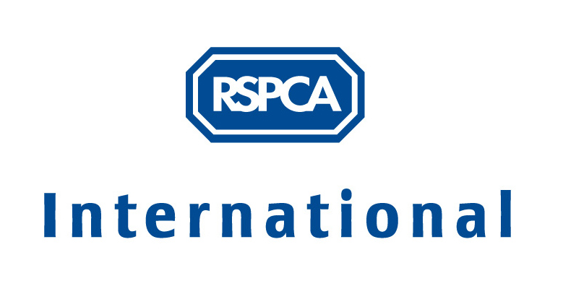

Developing a fund-raising strategy

- Identify and prioritise your organisation’s goals and funding needs
- Local or national priorities for animal welfare
- Short-term and long-term
- Capital development
- Running costs

- Identify sources of funding

Get committee, staff and volunteers together to come up with as many ideas as you can think of, e.g.:
- Grant-making organisations
- Local authority
- Government departments
- Companies – sponsorship, gifts in kind, advertising
- Public - one-off donations, events
- Public committed giving and sponsorship

- Examine pros and cons of the different sources of funding, e.g.:
- Restricted or unrestricted donations
- Regular or sporadic income
- Time, personnel and skills required
- Planning process – time involved v. benefits yielded
- Ongoing monitoring requirements – e.g. grant-making trusts
- Ongoing information requirements (time and cost) - e.g. donor newsletters
- Publicity and recognition
- Relationship building – e.g. local authority, companies
- Lobbying – time v. opportunity to raise issues
- Risk of loss of independence – commitment to specific activities / contract

- Establish what each donor will give money for

Donors give for different reasons and will fund different requirements. You will need to research what your identified potential donors are likely to support, e.g. through initial discussions. Grant-making trusts each have their own criteria for what projects they will fund, to meet their own objectives, and it is always advisable to check these criteria before spending time on a detailed application. Discussing the donors’ perspective with them will enable you to develop a suitable “marketing” approach – see 7 below. In some cases your research may be less direct e.g. in organising social events or making public appeals, you could check local papers to see what events have been successful for different audiences, or what issues are currently topical that you could respond to or use as a theme. For members, conducting a survey of their main concerns is an option.

- Match donors to your needs

Draw up a list of the donors it would be appropriate to approach according to your different funding needs, and prioritise these according to the time and resources required and that you have available. Consider the appropriate balance for your organisation between the convenience but vulnerability of having a single major donor source, and the time involved but ability to spread risk of funding through having a diverse funding base.

It is important that the needs your organisation has identified determine the donors you will approach rather than coming up with a new project just because you think funding is available. Otherwise you may get funds for a project that is not a priority which you will have to carry out, reducing time and people available to spend on fund-raising for the main needs. With applications to grant-making trusts, it is necessary to demonstrate the need and that the project plan has been thought through; spontaneous projects may come across as random or unfocused.

- Develop your “marketing” approach

Decide how you will describe your project to appeal to different donors. This means understanding the outcomes the donor is likely to support and outlining your proposal in light of this. For example, for an animal welfare grant-making trust, the outcomes will be in terms of animals that will benefit; whereas for a company, the outcomes may be in the number of visitors to your shelter or the number of members who will receive your newsletter, and hence see their advertising.

- Set your fund-raising objectives and draw up an action plan

Think through the steps required for you to reach your fund-raising goals and write these down in one document. The plan should include:

- Goals – what you want to achieve e.g. raising £6,000 to build a clinic facility at your shelter.
- Objectives - the targets you need to achieve to meet your goal e.g. encourage veterinary equipment suppliers to donate equipment; recruit volunteers to help with fundraising events
- Methods – what specific fund-raising activities you will carry out e.g. write a proposal to veterinary equipment suppliers or grant-making trusts, organise a sponsored fun-run, recruit new donors through a membership drive, secure media interest
- Evaluation – how you will assess what worked well and what didn’t, so you can learn which methods to use or avoid again, and how to refine future plans. If you are applying to grant-making trusts you may be required to provide a formal evaluation of your project, showing to what extent your original aims and objectives for the project have been met. This may require you to set up monitoring systems at the outset of the project to gather necessary data.

Your action plan may be fairly loose and flexible, outlining key activities and time frames, or it may be more detailed with details of who is responsible for each specific task, deadlines, budgets etc.

N. B. You will need to check the time-scales for applications to grant making trusts (some consider applications only once or twice a year at fixed times), and be aware of key dates on the political calendar e.g. elections and department budget setting.

- Develop the resources needed

To implement your action plan, you will need to put in place the necessary resources. The resources you require will vary according to the fund-raising methods you are going to use. In most cases a budget will be required, and this should contain realistic estimates of both income and expenditure. Other resources may be a detailed project plan (e.g. for grant-making trusts or local authorities), a project team (e.g. for organising events), volunteers, publicity material, etc.

- Review of activities and fund-raising strategy overall

Review how well your fund-raising strategy is operating in practice at regular intervals - to keep on track, share feedback, support each other and boost morale, make any necessary changes, etc.

