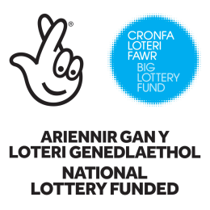
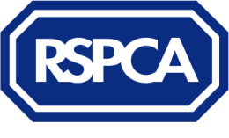
Thank you for your interest in the RSPCA’s Animal Action Project for Wales which is taking place in Colwyn Bay and funded by Big Lottery Wales. The Animal Action Day is running on both the 8th and 9th of August 2018, and children and their carers will be invited to attend one of the two days.
We have a fantastic day of activities planned at an RSPCA animal centre to help children and their foster parent/s learn about caring for animals; including a practical session with an RSPCA Inspector and a tour of our centre to learn about the special animals that come into RSPCA care and the work we do rescuing, rehabilitating and re-homing them. Children and parents will also take part in a fun session learning about dog behaviour and the secret language of dogs. In addition to the Animal Action Day, we are also running 3 x 2 hour workshops for those children who need more support. More information about this will be available on the day.
Through Education we hope to reduce the risk of children harming animals and increase positive attitudes and interactions with animals, increase the sustainability of placements and keep children safe around dogs, both in the home and outdoors.
We have 16 places per location for Looked After Children aged 7-16. Places will first be allocated to those who are most likely to benefit from the project. For us to assess this for each child, please complete this form before the deadline on 13th July at 4pm. You need to complete one form per child.
Please only complete this form if you personally have appropriate and proper authority to make a referral and share the child’s personal data. In addition to the referral form, you will also find a privacy notice which explains how the data you provide to us will be used in line with Data Protection legislation. Please read through this and complete the declaration by ticking the boxes at the end of the form, otherwise we will not be able to use this information to contact foster parents with their child's course invitation, or provide an appropriate level of support for the child.
Please complete the referral form and the privacy form and e mail securely back to kate.oregan@rspca.org.uk
If you have any queries, or have any difficulties completing the form please contact Kate O'Regan at kate.oregan@rspca.org.uk, 07715540622.
Child’s first name: | Age: | Gender:
Name of person making the referral: | Job title:  Agency/organisation: | Contact details:  Email:  Phone:
Name of person(s) accompanying the child: | Contact details:  Email:  Phone:
The Animal Action Days are for a maximum of 8 children per session. At this session, children will be assessed and some children will be invited  to attend 3 x 2 hour sessions for continued intervention work to meet their needs. These will not take place during school time but in the school holidays and the weekend. | Please confirm that the carer/s and child would be able to attend a day session at an animal centre AND commit to the 3 x 2 hour sessions if their child is assessed to need further support.  (Please highlight):  Yes / No | Please confirm that the carer/s and child are prepared to complete a short pre-session evaluation and provide feedback during and after the project. (Please highlight):  Yes / No
Please give details about why you would like to nominate the child to take part in the Animal Action Project.

Please give any details about animals in the home and the child’s behaviour towards them.

Have there been any reports of inappropriate behaviour towards animals by the child? Please give details:

Does the child have any additional needs (SEND) for which we would need to offer provision for? Please give details:

Does the child understand Welsh and/ or English? Please highlight: Welsh only / English only / Welsh and English
Other – Please give details
I confirm I have the authority and right to provide the information about the child and give consent to participation in the Animal Action Project programme. Yes / No
Please e mail this form to:
kate.oregan@rspca.org.uk by 4pm on 13th July 2018

Thankyou for completing the referral form. We will contact the foster parents whose children have been successful in gaining a place directly. Please ask parent/s to keep both 8th and 9th August free until places have been allocated. (They will only be attending one of those days.) If you have any queries or questions please contact Kate O'Regan at kate.oregan@rspca.org.uk , 07715540622
The data protection and privacy statement has been e mailed separately – please read, complete and e mail back to us. Without this, the referral is not complete.

