Aims and objectives
- This activity is just one part of a range of resources addressing the needs of young people who have been involved, or who are at risk of being involved, in cruelty to animals. Our online assessment tool Developing a suitable intervention programme (Word 17KB) will help you create individualised intervention programmes from these resources.
- In this activity, young people are asked what society would expect them to do if they came across animals that were not theirs, but were obviously suffering.
- Young people will develop:
  - the understanding that society expects us to care for and help not only our own animals, but also any that do not belong to us, or any wild animals that are in need
  - knowledge about what to do in situations similar to those in the scenarios
  - empathy with wild and farm animals.

What to do

- Look at the pictures and stories in the activity sheet Taking responsibility. Take care when choosing which pictures to look at – they may be distressing for some young people.
- Ask the young person the following questions.
  - What would you do if you found an animal or animals suffering like that?
  - Could you help them?
  - How do you think you could help?
- Read the facilitators’ notes Taking control. Explain that every year the RSPCA National Control Centre gets thousands of calls from the public, asking for advice on how to help trapped, injured or sick wild or farm animals.
- Ask the young person the following questions.
  - Could you imagine yourself ringing the RSPCA for advice on how to help an animal?
  - How do you think it would make you feel if you managed to help this/these animals?
  - It is fairly common for people to go out of their way to help animals that are not, strictly speaking, their responsibility. Why do you think that is? What do they get out of it?
  - What do you think other people would think about you if you helped these animals?
  - Do wild animals count for less because they don’t have an owner? Would they be able to feel the same amount of pain and fear as any other animal?
  - Do farm animals feel pain like other animals? Does it matter if they’re going to be killed for meat in the end anyway?
- Try to lead the young person to an understanding that most of society values all animals and does not like to think of animals suffering. Even if an animal will be killed for food production eventually, the RSPCA and a large section of the public thinks this is no reason for them to suffer throughout their lives. Scientists agree that ALL vertebrates feel pain and, more importantly, suffer. There is increasing evidence that invertebrates, such as crab and squid do too.
- We have also developed three interactive activities - Was it cruel?, Consequences and Triggers - that help young people think through what happens when people are cruel to animals (see right). However, before you attempt to use these, we suggest that you explore some of the activities in the other sections - What is animal cruelty?, What triggers animals cruelty and how it can be avoided, Consequences of cruelty to animals and The incident.

Activity sheet – Taking responsibility (1)

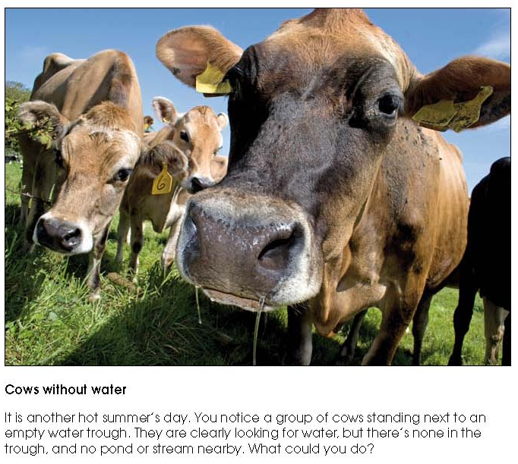
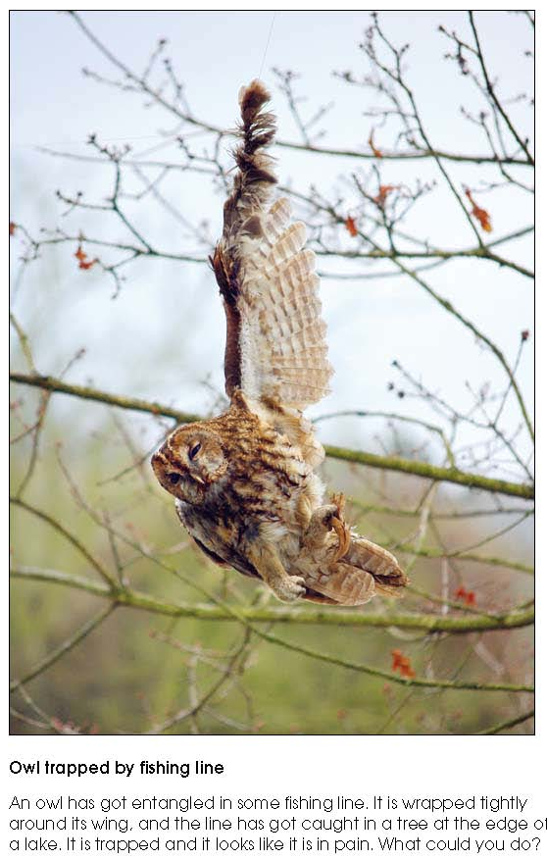
Activity sheet – Taking responsibility (2)

Facilitators’ notes – Taking control

