This lesson can be used to introduce pupils to the concept of human and animal (pet) needs.

Starter activity
Humans and animals
- Draw a simple smiley face in the middle of the whiteboard or on a piece of paper.
- Ask the pupils what they think they need to be healthy and happy. Place the word cards you have prepared around the drawing of the child as the pupils suggest them. Have a few spare blank cards on which to write any other suggestions the pupils may make.
- Show them a photo of one of the pets from the images collection Pets. Ask the pupils to name the animal. Explain that it is a pet and that people keep pets because they like them and they enjoy looking after them.
- Place the photo of the pet over the smiley face or turn the smiley face into the face of a pet animal. Ask the pupils to think about all the different things the pet needs. Are some of them the same as a child needs?
Learning styles: visual, auditory.

Main activity
Pet detectives
- Before the lesson set up five ‘Pet Detective’ bags. Each bag should contain a selection of objects relating to the basic needs of that pet. The objects provide clues to help the pupils decide which pet they relate to. An alternative to the bags would be to use the images included in this lesson (see Download section)
- Ask the pupils to work in groups and to pick things out of the bag one by one. Discuss what each item is and how they think it is used to when looking after an animal.
- After everything has come out of the bag, ask the pupils to try to guess what type of animal needs all the things in their bag.
- One pupil from each group then chooses the appropriate Pets image.
- Ask pupils to think of anything else they might need to look after the animal and to ensure that all the needs were met.
Learning styles: visual, auditory, kinaesthetic.

Plenary activity
Final round up
- Ask each group to share which animal and explain how the objects in the bag would be used to meet the pet’s needs.
- Were there any other items they would need to meet all of the pet’s needs
- Watch pet care clip What do pets need?
- As a class discuss who’s responsibility it is to make sure that pet needs are met.
Learning styles: visual, kinaesthetic,

Extension activities
- Ask pupils to think of a pet and then write a list or draw pictures of the things that pet would need to keep them happy and healthy. Pupils ask an elbow partner to guess what their animal is. To make this more challenging they could include one odd one out item which the pet doesn’t need.
- Work through the pets flipcharts on the Promethean Planet website.
- Watch the videos in the Useful websites. Ask the pupils to suggest some of the things they have learnt about what pets need.
- Explore Pets and Animals needs sections of the Animals and Us interactive either individually or as a class.

Curriculum objectives
Pupils should learn:
- that all humans have needs
- that all animals have needs
- in group discussions, to take different views into account while developing their ideas.

Learning outcomes
At the end of this lesson:
- most pupils: know that animals have needs just like humans and that these needs include food, water, companionship, a suitable place to live, being looked after by a vet if they are ill, and the freedom to behave naturally
- some pupils have not made so much progress and: know that animals have needs just like humans
- some pupils have progressed further and: know that animals have needs just like humans, and that these needs include food, water, companionship, a suitable place to live, being looked after by a vet if they are ill and the freedom to behave naturally They begin to appreciate the ways in which humans have a responsibility and duty of care towards pets.

Vocabulary
aviary basket blanket bowls care cat flap collar
doctor drink food friends grooming habitat healthy
home hutch identity disc lead medicine run
tank toys vet

Useful websites
RSPCA - All about animals - General pet care
Animals and US Interactive
Pets flipcharts - Promethean Planet
Video - What do pets need?
Video - Happy bunnies

Worksheet – What we need

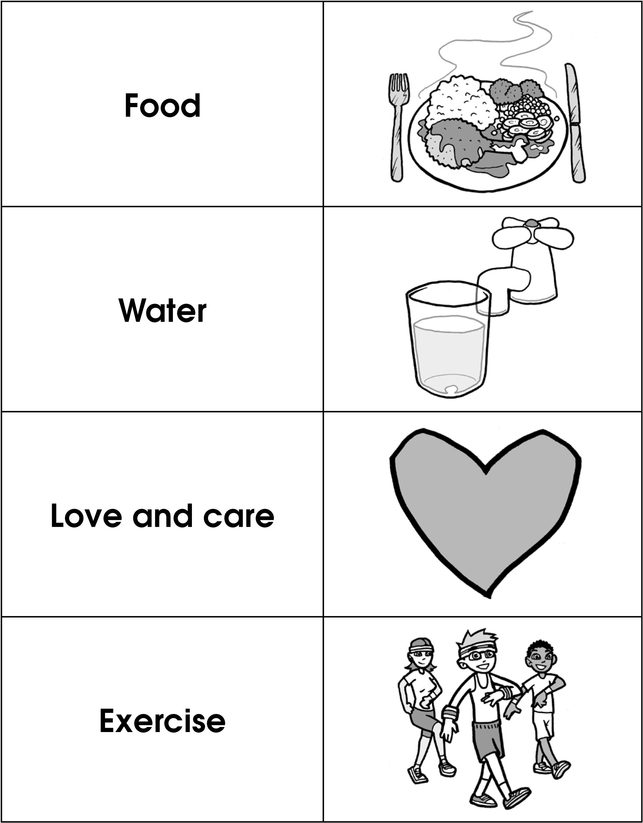

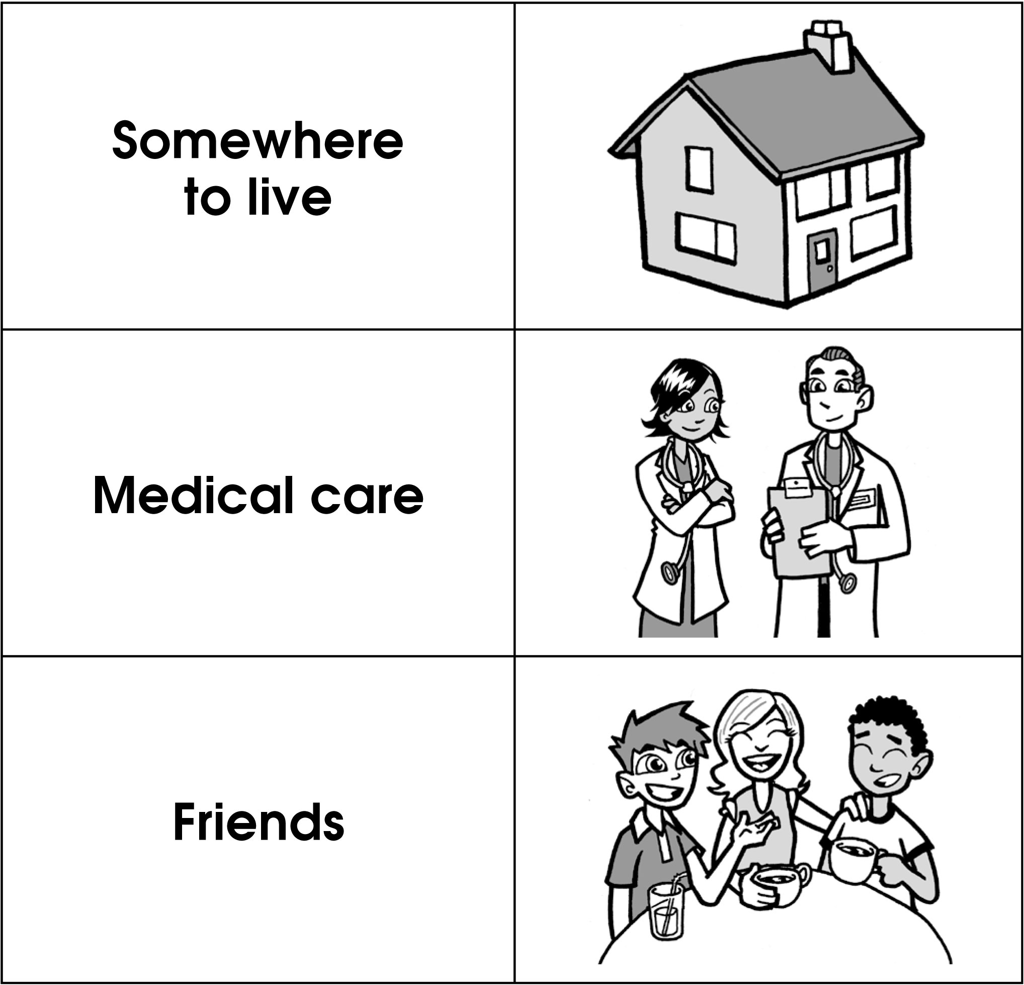

Worksheet – What cats need

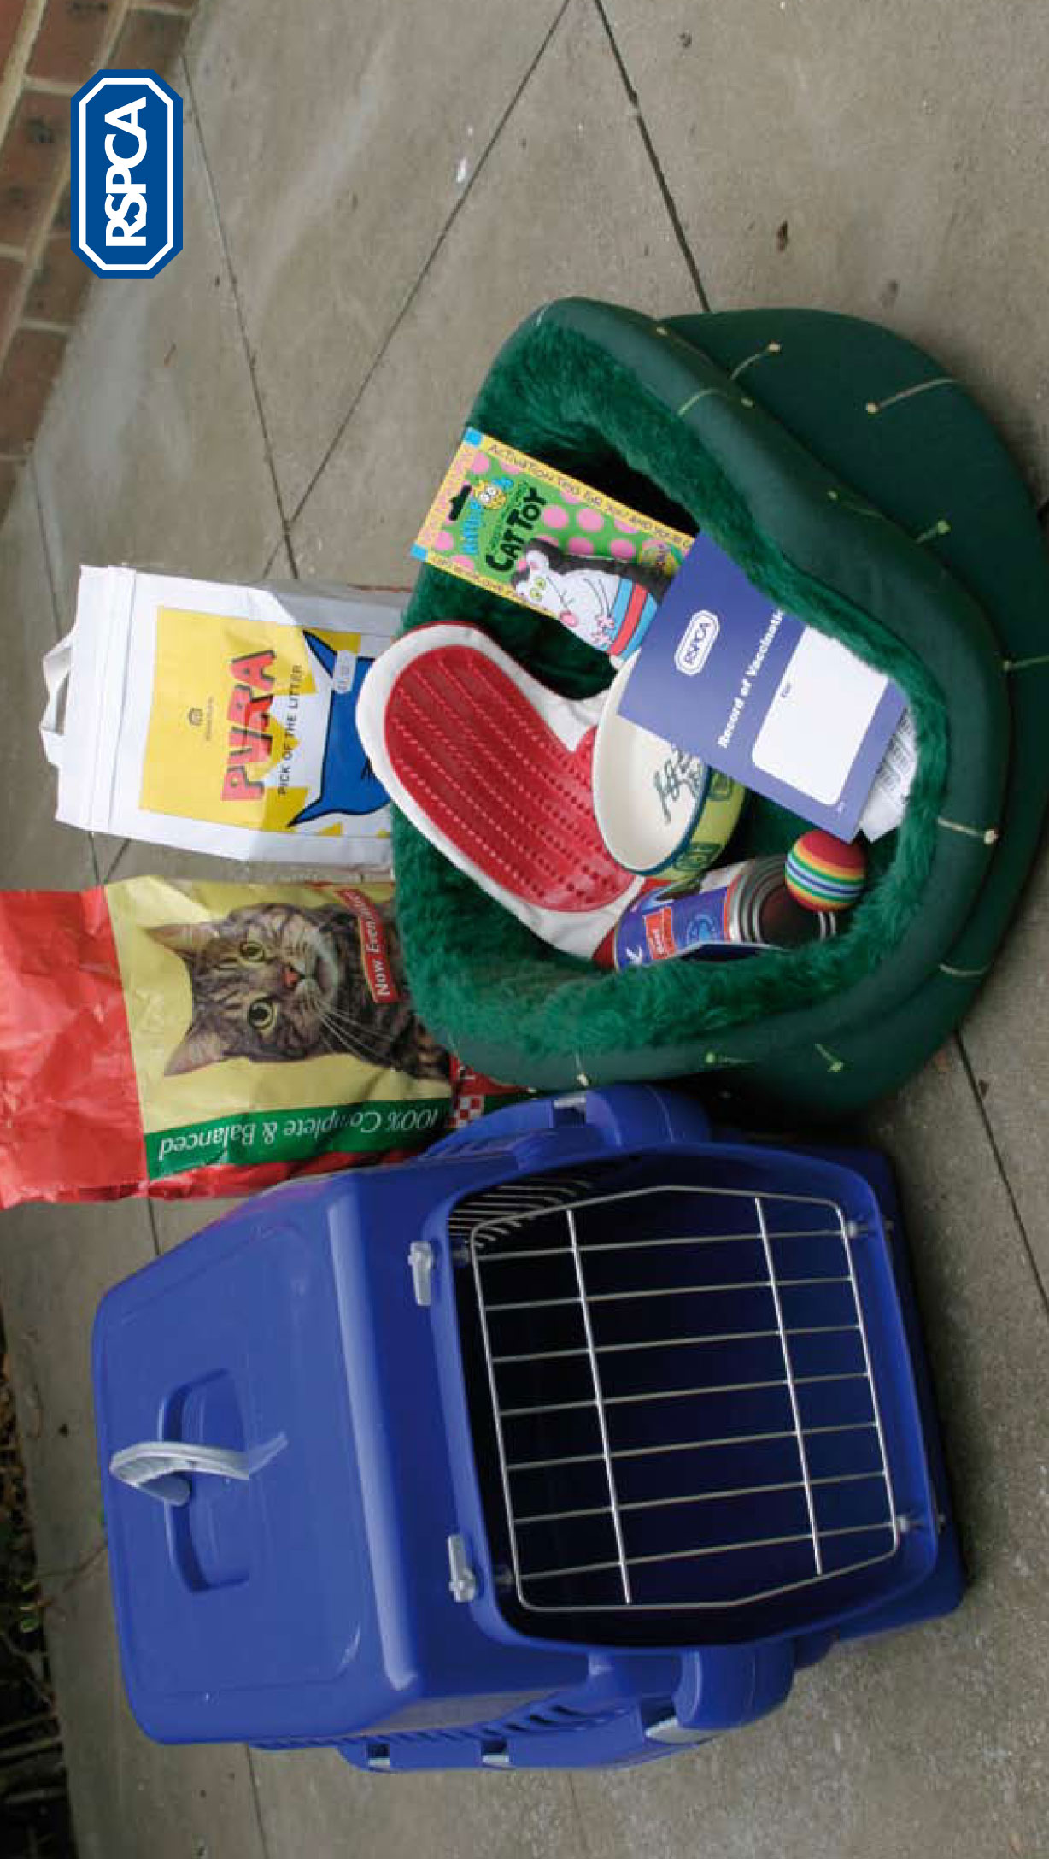

Worksheet – What dogs need

