In this lesson, students will consider the impact of advances in genetic alteration on animals and the consequences for animal welfare.

Starter activity
What is animal engineering?
- Give students in pairs the worksheet What is animal engineering? and ask them to match type of Animal engineering with its definition and its uses. Use the teachers notes Genetically altered animals to help you
- Introduce students to the idea of benefits and harms of genetically altering animals and the ethical debate around it, using some examples from the teachers’ notes
Learning styles: visual, auditory, kinaesthetic.

Main activity
Press conference
- Explain to students that the focus is now on genetic alteration, and that to discuss the issues associated with genetic alteration, they are invited to conduct a role play of a press conference. The purpose of the press conference is to unveil a genetically-altered goat that produces the new (fictional) drug ClotBlock® in its milk.
- Give all students a copy of the factsheet ClotBlock® to read.
- Identify students to take on the following characters in the panel:
- chairperson
- research scientist
- doctor
- RSPCA scientific officer
- patient
- the goat.
- Give each character a factsheet relevant to their specific role and ask them to prepare a brief statement to be read out at the start of the press conference.
- Ask the other students in the class to be journalists, and give them time to prepare questions to ask the panel members.
- Arrange the classroom with the panel members at the front of the class.
- Ask the chairperson to start the press conference by introducing each panel member, who will read out the brief statements they have prepared in turn, outlining their views on the drug ClotBlock®.
- Conduct a role play of the press conference. The chairperson should chair the discussion and allow the journalists to put their questions to the panel members.
Learning styles: visual, auditory.

Plenary activity
Is it acceptable?
- Following the role play give each student a copy of the worksheet Is it acceptable? Ask them to sort the statements into two categories - those that they agree with and those that they disagree with. Invite the class to compare and discuss their answers.
Learning styles: visual, auditory, kinaesthetic.

Differentiation
Differentiation is possible in the main activity with panel members having a more challenging role than the journalists.

Assessment
- Questions asked during press conference.

Extension activities
- Students could write a newspaper report based on the press conference, including a catchy headline.
- Compare the students' views on genetic alteration of animals before and after completing the main activities.
- Compare the views of students with the views of the press conference characters.
- Give students a list of engineered animals (How far have humans gone? (a)) and ask them to put the animals in the appropriate places on the venn diagram (How far have humans gone? (b)) according to whether the animal has been selectively bred, cloned and/or genetically altered by humans.

Did you know?
- The number of genetically-altered (GA) animals used in research is rising, and is contributing to an overall rise in the number of animals. The number of procedures involving GA animals increased from 1.04 million in 2006 to 2.4 million in 2012.
- In 2012, GA animals (mainly mice) were used in 59% of all scientific procedures compared to 34% in 2006.
- In 2012, 4.11 million scientific procedures, involving around 4.03 million animals, were carried out on animals in the UK.

Curriculum objectives
Students should learn:
- to consider examples of genetically altered animals, the reasons for this research and some of the ethical questions and debates
- to consider one example of a genetically altered animal used for developing a new medicine, exploring from several perspectives the costs (harms) to animals and potential benefits to humans.

Animal welfare objectives
Students should learn:
- to consider the impact that genetic alteration has on animal health and welfare
- to consider the ethical and moral issues that arise as a result of the genetic alteration of animals.

Learning outcomes
At the end of this lesson:
- most students will: understand that animals are genetically altered by humans for use in medical, commercial and basic research, that this research will have costs to animals and may have benefit to humans and that there are ethical questions to consider
- some students have not made so much progress and: are able to state examples of animals that have been genetically altered and that there are different views about this
- some students have progressed further and: can consider and reflect on their own attitudes towards genetic alteration and the ethical issues involved.

Vocabulary
clone / cloning DNA genetic engineering animal engineering
genetic alteration genetically modified selective breeding / selectively bred

Useful websites
RSPCA - All about animals - Laboratory animals
RSPCA - Biotechnology
Animals (Scientific Procedures) Act 1986
Home Office - Research and testing using animals

Worksheet – Is it acceptable?

Consider the statements below and sort them into two categories - those you agree with and those you disagree with.

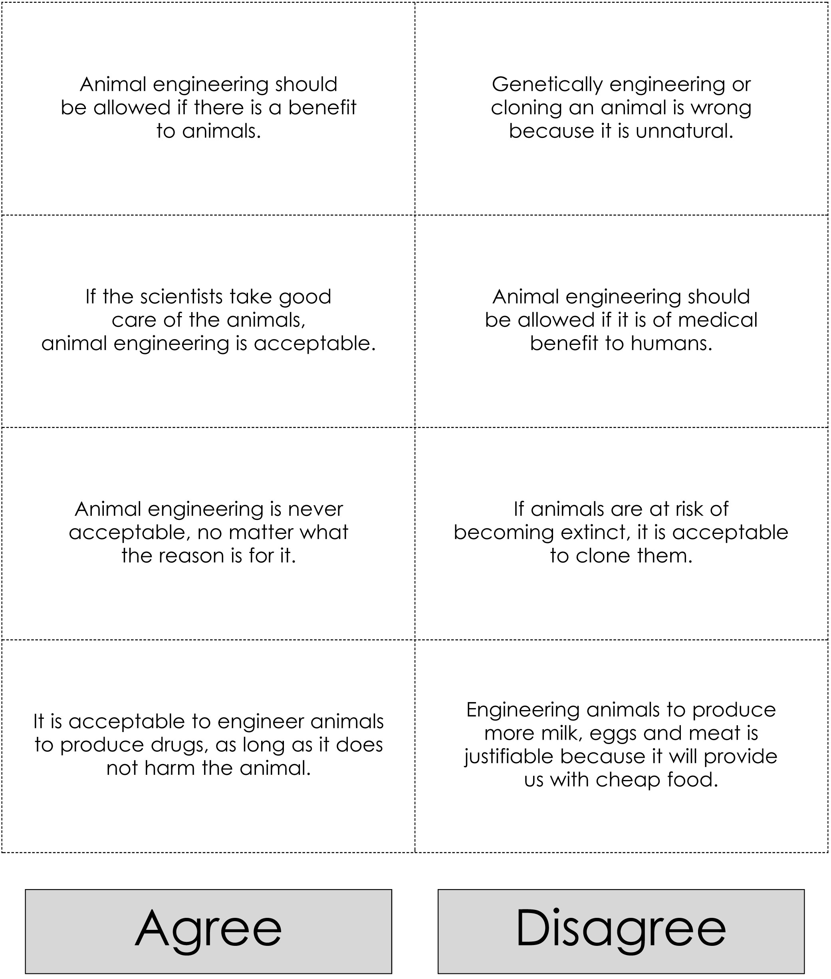
Worksheet – How far have humans gone?

Put each of the animals listed below into one of the circles on the worksheet How far have humans gone? (b). Identify whether you think humans have tried to selectively breed, clone or genetically alter the animals. If you think an animal falls into more than one category, place it in the area of overlap between the categories.

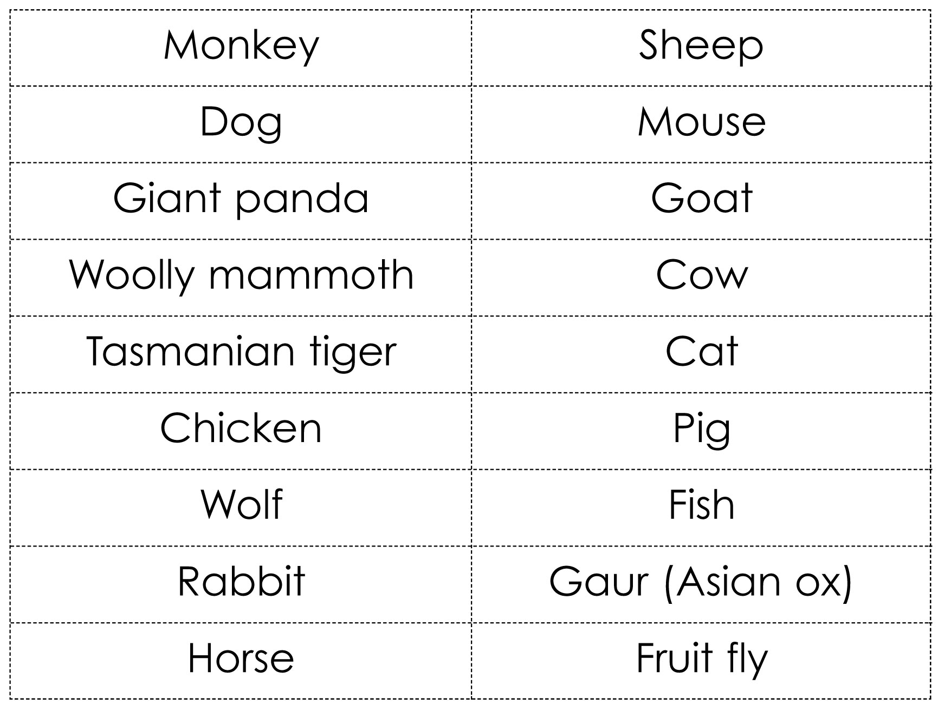

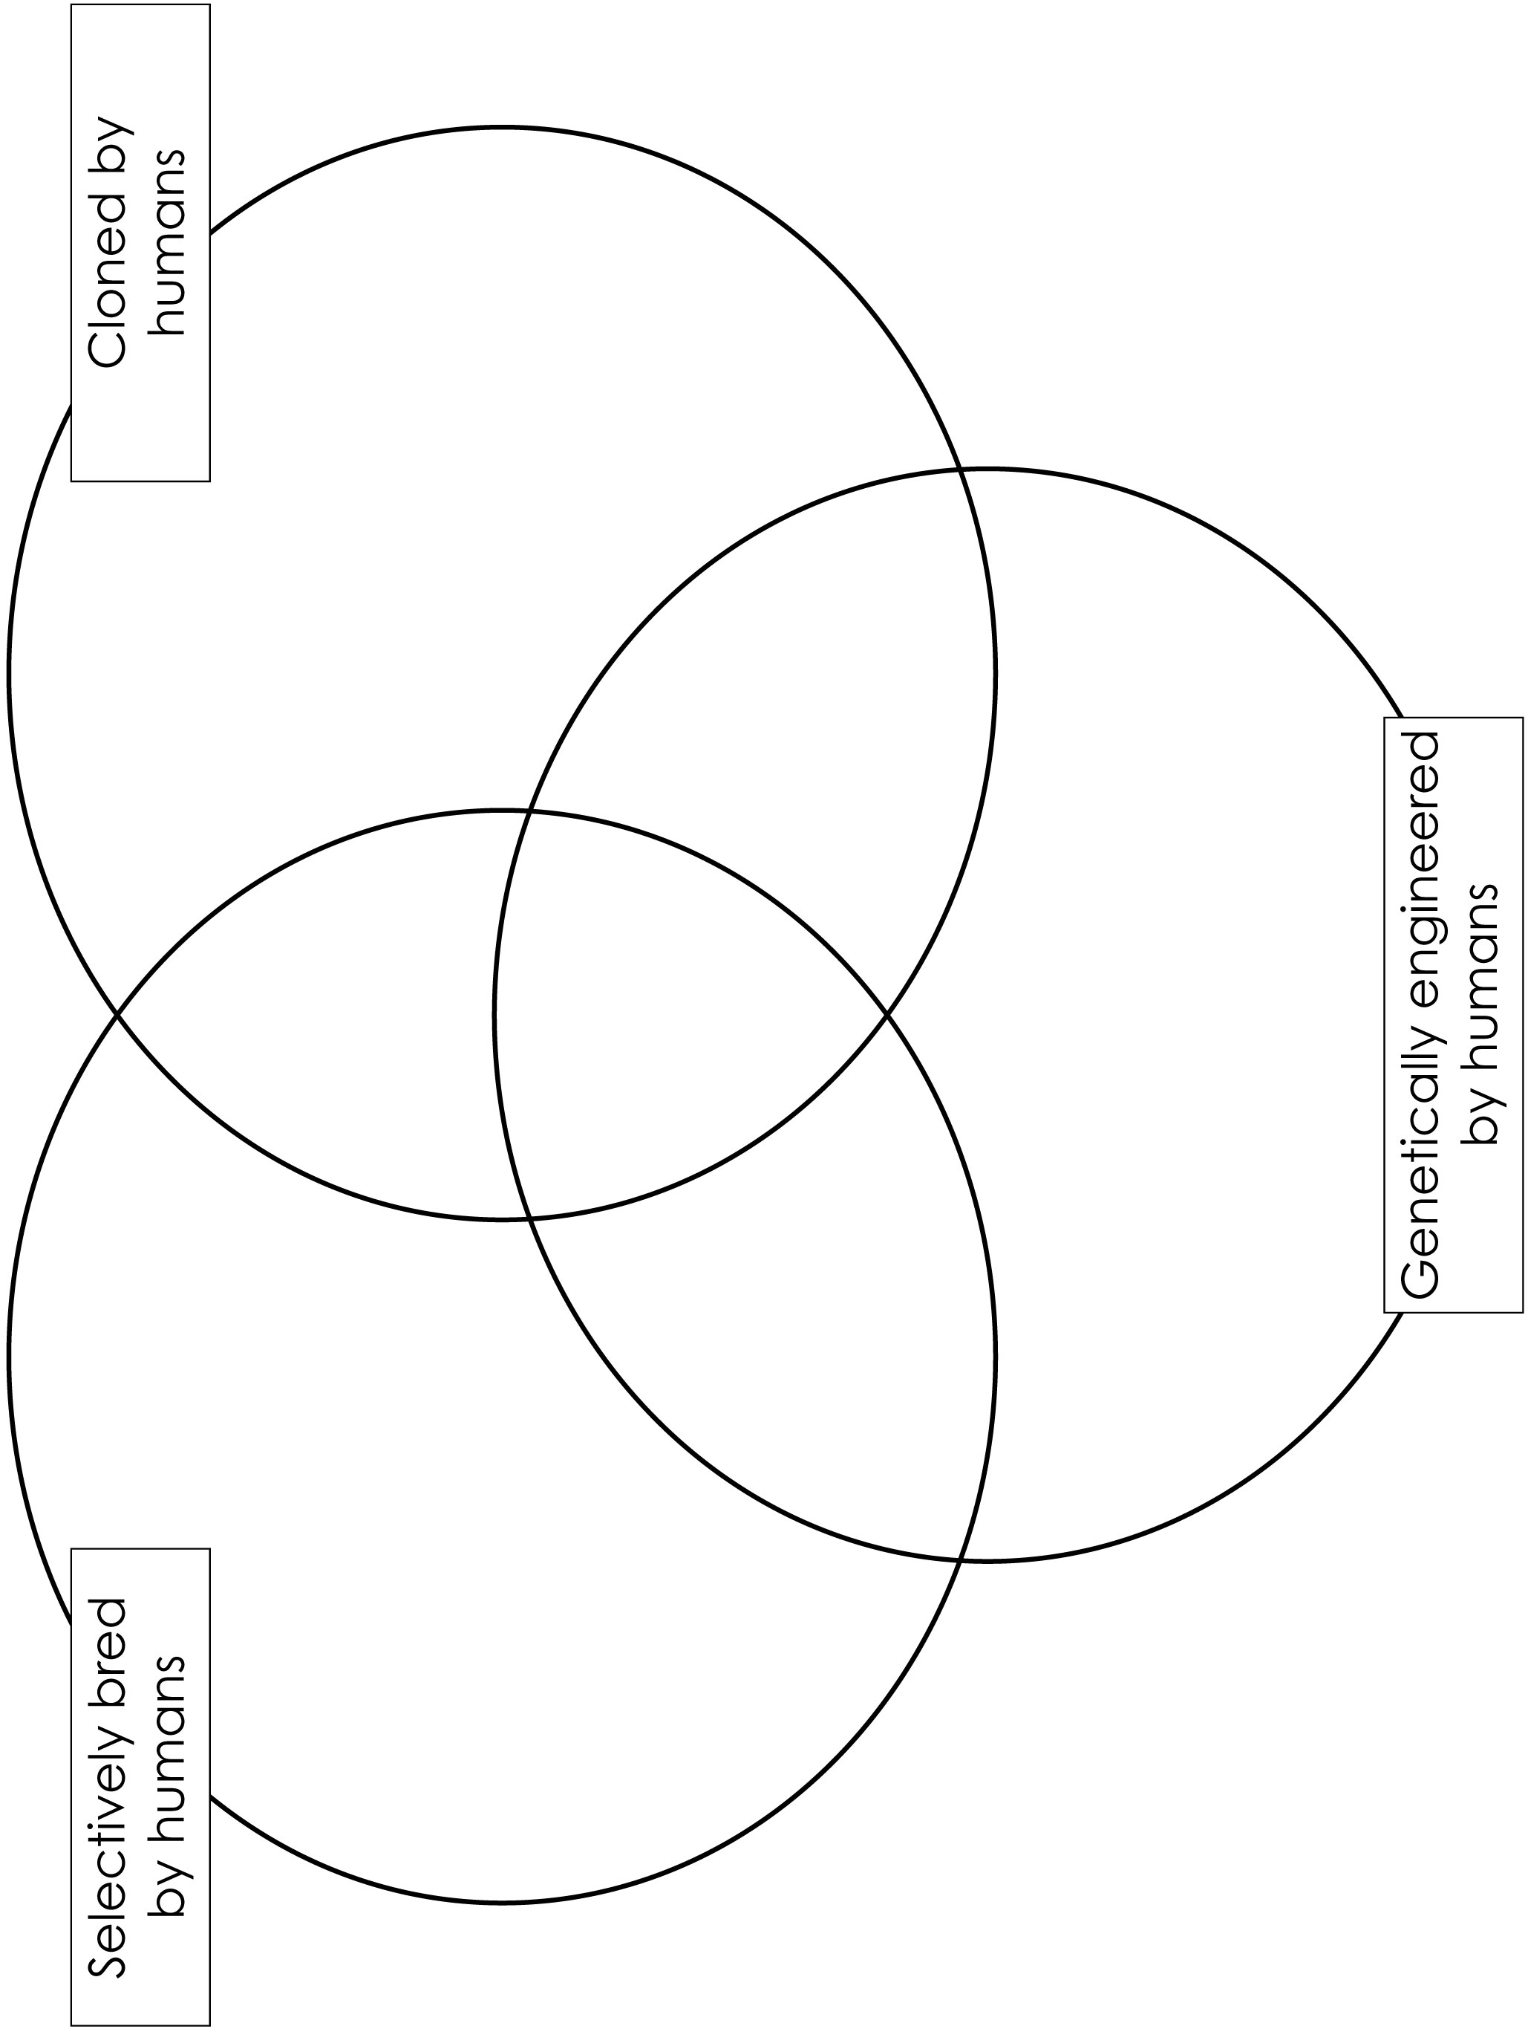

Worksheet – How far have humans gone? answers

Monkey - scientists in America have made several attempts to clone monkeys but, to date, these have been unsuccessful. The closest efforts resulted in ‘Tetra’ who is the genetically identical twin of another monkey embryo. However, these scientists have genetically altered a monkey called ANDi.

Dog - these animals have been selectively bred for many years, primarily for their
looks but also for their temperament and working skills. Scientists in South Korea
have cloned a dog to create a clone called ‘Snuppy’.

Giant panda - scientists in China have created cloned embryos from giant pandas, but no cloned pandas have been born yet.

Woolly mammoth - Russian and Japanese scientists have tried to clone this extinct animal but, as yet, attempts have proved unsuccessful.

Tasmanian tiger - Australian scientists tried to clone this extinct animal but were not successful and have since abandoned this research.

Chicken - these birds have been selectively bred by humans over many years for a faster growth rate and increased egg production. More recently, they have been selectively bred with a featherless species of bird to create featherless chickens. Scientists in Scotland have also genetically altered chickens to lay eggs containing drugs for human use but, as yet, chickens have not been cloned.

Wolf - scientists in South Korea have produced two cloned wolves from a gray wolf at Seoul Zoo.

Sheep - these animals have been selectively bred by humans for many years for their meat and wool. Sheep have also been cloned by scientists in Scotland (Dolly) and genetically altered by scientists in Australia.

Mouse - these animals have been selectively bred within laboratories since the 1970s. Mice are now routinely genetically altered for research purposes, and American scientists have produced the first cloned mouse called Cumulina.

Goat - these animals have been selectively bred by humans for many years for their milk and wool. Goats have also been genetically altered to produce drugs and other products in their milk, and cloned by scientists in China.

Cow - these animals have been selectively bred by humans for their milk and meat, as well as genetically altered and cloned.

Cat - these animals have been selectively bred for many years, primarily for their looks. Scientists have also tried to genetically alter cats, however no such animal has yet been made public. Cats have been cloned but this is not routinely done. A company in America once advertised a service to clone pet cats but it later closed down due to a lack of demand.

Pig - these animals have been selectively bred for many years, primarily for their meat, e.g. increased meat production and leaner meat. Pigs have also been genetically altered for research purposes or to produce organs and tissue for transplantation into humans. Similarly, scientists around the world have been successful in cloning pigs.

Fish - these animals are selectively bred as part of the farming process for their reproductive success and growth rate. Fish are also routinely genetically altered by humans for research purposes, and have been engineered for commercial purposes to further increase growth rates. Fish have also been cloned.

Rabbit - these animals have been selectively bred for many years for their fur and their meat. Scientists have also genetically altered rabbits, as well as cloning them.

Gaur - this species of rare Asian ox has been cloned but the first clone, ‘Noah’, only lived for a few days.

Horse - these animals are routinely selectively bred for a number of different characteristics. To date, horses have not been successfully genetically altered, but some sports horses have been cloned.

Fruit fly - these insects have been selectively bred for research purposes. They are also routinely genetically modified and have been cloned.
Factsheet – ClotBlock®

Background information for the press conference
ClotBlock® is a fictional drug produced in the milk of a genetically-engineered goat.

ClotBlock® will be used to treat people with antithrombin (AT) deficiency (a real disease). AT deficiency is a rare, hereditary disease affecting approximately one person in every 3,000 to 5,000. This disease means that the person’s blood forms clots when it should not. Therefore, sufferers are at risk of developing dangerous blood-clotting conditions, such as deep vein thrombosis at any time.

Currently, sufferers are treated with antithrombin (a natural substance that prevents blood clots from forming when they should not), obtained from blood plasma that has been removed from donated human blood. However, there is a high demand for donated blood, which can be in limited supply. Therefore, an alternative source of antithrombin has been developed.

The drug ClotBlock® is removed from the milk produced by the geneticallyengineered goat and processed into a pill. It is claimed that, in a single year, one genetically-engineered goat could produce the same amount of antithrombin (used to make ClotBlock®) as 90,000 blood donations.

Journalist activity:
Prepare a list of questions to ask the panel members during the press conference.

The panel consists of:
- a research scientist
- a doctor
- an RSPCA scientific officer
- a patient
- a genetically-engineered goat.

Factsheet – Character information sheets

Chairperson

Your role:
The chairperson is responsible for ensuring that everyone at the press conference is given a chance to speak, and that the journalists get answers to as many questions as possible within the time provided.

Activity:
- Start the press conference by introducing your audience to the drug ClotBlock® using the text provided in the factsheet.
- Introduce each of the panel members in turn. Ask them to make a brief statement about their thoughts on genetically altering goats to produce drugs for humans.
- Encourage journalists to put any questions they may have about ClotBlock® to the panel members and to try to ensure these questions are answered.
Research Scientist

Your role:
You represent all the scientists that have worked over the last 15 years to create the genetically altered goat that produces the drug ClotBlock® in its milk.

Background information:
Your research started when the human antithrombin (AT) gene was sequenced. You created a copy of the human gene that also contained a sequence of goat DNA that provided the information required to tell the goat’s body to produce the drug in the its milk.

The AT gene and goat DNA was injected into hundreds of goats’ eggs before fertilising them using sperm collected from male goats. The fertilised eggs were kept in the laboratory and allowed to develop into early-stage goat embryos. All the healthy goat embryos were then implanted into female goats. Some of the goat embryos died during the pregnancy, but those that survived were born six months later.

The kids (baby goats) were tested to see whether they carried the human AT gene and produced ClotBlock® in their milk. Those that did not express the human AT gene or produce ClotBlock® in their milk were either killed or used for other research purposes.

The goat being unveiled at the press conference today is the first goat that you and your team created to produce ClotBlock® in its milk.

Activity:
Write a brief statement, explaining why your character thinks the genetic alteration of goats to produce drugs for human use is a good thing.

Doctor

Your role:
You represent members of the medical profession that take care of patients with antithrombin (AT) deficiency.

Background:
AT deficiency was first described by doctors and researchers in 1965 and currently affects up to 20,000 people in the UK alone.

At present, there are two main treatments available. The first treatment involves patients taking anti-clotting medication on a daily basis, however long-term use can put patients at an increased risk of uncontrolled internal bleeding. It is also not always advisable for patients to take anti-clotting medication, for example, when undergoing surgery or having a baby.

In these circumstances, patients can be given human antithrombin, a naturallyoccurring
substance extracted from donated blood. However, there is a high demand for donated blood for transfusions and so there may not always be enough antithrombin available.

It would therefore be beneficial to have an alternative source of antithrombin for your patients.

Activity:
Write a brief statement, explaining whether your character thinks the genetic alteration of goats to produce drugs for human use is a good or a bad thing and why.

Patient

Your role:
You suffer from antithrombin (AT) deficiency and are representing the views of all AT deficiency sufferers around the world.

Background:
You take anti-clotting drugs daily to minimise the risk of life-threatening blood clots forming and blocking the blood supply to your brain, heart or lungs. However, this means that if you have an accident or cut yourself, there may be problems stopping any bleeding.

Similarly, if you need to undergo a surgical procedure, you have to stop taking the anti-clotting drugs so that your blood will clot normally, allowing your body to heal.

At present, the only alternative is to take human antithrombin, a naturally-occurring substance extracted from donated blood. However, there is a high demand for donated blood for transfusions and so the supply of antithrombin can be limited.

You therefore welcome the development of an alternative source of antithrombin. You do not mind how the drug is produced, as long as it is available when you need it.

Activity:
Write a brief statement, explaining why your character thinks the genetic alteration of goats to produce drugs for human use is a good thing.

RSPCA scientific officer

Your role:
You represent the views of the largest animal welfare organisation in the UK.

Background:
It has taken scientists 15 years to create the genetically-modified goat that is being unveiled at today’s press conference. During those 15 years, many animals will have been used, a large number of which will have lost their lives

Animals have been used to:
- supply thousands of goat eggs for injection with the human antithrombin (AT) gene
- supply sperm to fertilise the goats’ eggs once they have been injected
- act as surrogate mothers for genetically altered goat embryos.

Before the genetically altered goat you see today was produced, there will have been a number of other goats produced that may have:
- died before or after birth due to developmental defects
- been humanely killed because they were suffering or were in distress
- survived and carry the human AT gene, but do not produce antithrombin in their milk.

You know that there are many animal welfare concerns associated with genetic alteration including:
- Animals can experience pain, suffering and distress as a consequence of the scientific procedures in which they are involved, or as a result of attempts to genetically alter the animal
- Large numbers of animals are used throughout the process of creating a new genetically-modified animal, the majority of which will lose their lives
- The animals used or created by this research will have been kept in unnatural surroundings that can have a negative impact on the animals’ welfare. For example, they may have been kept in isolation rather than with their companions in herds
- By genetically altering an animal to produce a drug in its milk, you are increasing the perception of animals as objects for human use, rather than as animals with feelings and the ability to suffer.

You understand that there is a need to develop alternative sources of human antithrombin to help treat patients with AT deficiency. However, you question whether genetically modifying goats to produce antithrombin in their milk is the best or only way of doing so.

Activity:
Write a brief statement, explaining why your character thinks the genetic alteration of goats to produce drugs for human use is not a good idea.

Goat

Your role:
You are the star of today’s press conference. You are the first goat in the world to have been genetically altered to produce antithrombin in your milk.

Background:
You know nothing about how and why you have been created.

You can remember you were around two months old when the humans first took an interest in you. They gave you an injection before trying to get a small amount of milk from you. You lived with your mother and some other goats then, but you have not seen them for a while.

When you were around a year old, you became pregnant and gave birth to a kid goat six months later. It was after this that the humans took you into the milking parlour for the first time. This was quite scary because it was very noisy and there were lots of strange looking machines, but you’re used to it now.

Since then, the humans have been taking milk from you every day - once in the morning and once in the evening. At present, you live with a group of female goats in a big barn. The floor is made of concrete, but it is covered in a deep layer of straw. There is fresh water and food available at all times and a man comes once or twice a day to fill the reserves up. However, there is not much to do all day and you get quite bored.

Activity:
Write a brief statement, explaining whether your character thinks that it is acceptable to genetically alter goats to produce drugs for human use and why.
Worksheet – What is animal engineering?

Animal engineering is a term which includes:
- Genetic alteration of animals
- Cloning of animals
- Selective breeding of animals

Cut out the cards below and match each of the three terms with a definition and what it is used for.

Term: Genetically altered animal  Can also be called:  - genetically modified animal | Uses: To produce animals of a particular species, e.g. rare or endangered animals. Or to reproduce a genetically altered animal | Uses: To produce animals who are productive, e.g. litter size, number of eggs, milk volume; to produce animals with specific characteristics, e.g. short nose, colour of fur, length of legs
Definition: This is where humans have selected two animals with certain characteristics, e.g. increased muscle mass, and bred them together to create offspring with the same characteristics. It can involve either natural reproduction or IVF | Term: Cloned animal | Definition: This is where scientists have altered the normal sequence of an animal’s DNA, .e.g. a gene has been added, deleted or altered
Uses: To alter growth rate of animals; to create animals that are resistant to specific diseases; to create animals with organs that are suitable for transplant into humans | Term: Selectively bred animal | Definition: This is where the DNA from one animal has been used to produce other genetically identical animals. The genes of the new animal match those of the original animal exactly

Teachers notes – What is animal engineering? Answers

Term: Genetically altered animal  Can also be called:  - genetically modified animal | Definition: This is where scientists have altered the normal sequence of an animal’s DNA, .e.g. a gene has been added, deleted or altered | Uses: To alter growth rate of animals; to create animals that are resistant to specific diseases; to create animals with organs that are suitable for transplant into humans
Term: Selectively bred animal | Definition: This is where humans have selected two animals with certain characteristics, e.g. increased muscle mass, and bred them together to create offspring with the same characteristics. It can involve either natural reproduction or IVF | Uses: To produce animals who are productive, e.g. litter size, number of eggs, milk volume; to produce animals with specific characteristics, e.g. short nose, colour of fur, length of legs
Term: Cloned animal | Definition: This is where the DNA from one animal has been used to produce other genetically identical animals. The genes of the new animal match those of the original animal exactly | Uses: To produce animals of a particular species, e.g. rare or endangered animals. Or to reproduce a genetically altered animal

Teachers notes – Genetically altered animals

Science and ethics
When learning about genetic alteration of animals, it is important to consider both the costs (harms) to the animals and the perceived benefits to humans, or other animals, and weigh these against each other. An individual’s view of whether it is acceptable to genetically alter an animal will also be influenced by whether they believe it is morally acceptable for humans to ‘play god’ and alter the genetic make-up of other animals.
Examples of the genetic alteration of animals

Examples of research | Reasons | Welfare concerns for genetically altered animals
Altering the growth rate of animals or the composition of food products, e.g. milk, meat or eggs. | To improve the yield or nutritional value of a food product for human consumption. | A large number of animals are killed during the process of creating a genetically altered animal. Animals are used as: a source of sperm or eggs to be genetically altered; mothers for carrying and giving birth to the new animals; and for maintaining breeding colonies of genetically altered animals for use in research and testing.  As animals may undergo surgery and be given injections, there is the potential that they may suffer from pain and distress.  When untargeted techniques are used to produce genetically altered animals it is difficult for scientists to predict the ‘benefits’, or the actual effects that the genetic alteration will have on their health and welfare (‘costs’).  As technology develops, so the number of animals and the range of species created and used for research and testing continues to rise every year.  Genetically altering animals for disease resistance may encourage poorer standards of animal care by permitting less frequent health checks.  Genetically altered animals used in research and testing may be viewed as ‘tools’ for human use rather than as individual animals.
Creating animals to produce biological substances in their eggs or milk that they would not normally produce. | To provide cheap methods for producing large quantities of biological substances for medicinal, research or commercial use.
Creating cows that are resistant to BSE (a nasty brain disease). | To reduce BSE in cattle and help prevent the spread of BSE to humans.
Creating fish that change colour in the presence of environmental pollutants. | To provide a quick and easy indication of the presence of pollutants in water. (‘Glofish’ are bred for sale as a novelty pet.)
Creating an animal (e.g. a pig) with organs that are suitable for transplantation into humans. | There is a shortage of human organs for transplantation and animal organs are normally rejected by the human immune system.
Creating a pig that produces manure with a lower-than-normal level of phosphorus. | Phosphorus in pig manure is a big environmental pollutant that kills fish and other organisms when it gets into ponds and streams.
Creating an animal ‘model’ of a human or animal illness, e.g. using sheep. | To learn more about the causes of the illness or help develop treatments or cures.
Creating animals that have had their DNA altered in some way, e.g. mice and zebrafish. | To learn more about the function of a specific gene during the lifespan of the animal or during the course of an illness.
Creating an animal with cells that glow in the dark, e.g. using rabbits of pigs. | For use in scientific research or to display as ‘living art’.

