This fun lesson explores the differences between caged hens and free-range hens kept for commercial egg production and the associated welfare issues. Pupils learn to identify the method of production from the information given on the egg box.

Starter activity
What hens need
- Show the class an egg box and explain that they will learn about the hens that laid the eggs.
- Hens need certain things to be happy and healthy. One of their needs is to behave normally - to do all of the things they like to do. These include:
- flapping their wings
- being with other hens
- pecking and scratching at the ground
- having nests to lay eggs in
- dustbathing
- sleeping on a perch at night.
- Sing the Happy hens song (to the tune of 'If you're happy and you know it'). For each verse, add an example of hens' normal behaviour, e.g. 'If you're happy and you know it, flap your wings' or 'peck the ground'.
Learning styles: visual, auditory.

Main activity
Being a hen
- Show two images, one of caged hens and the other of free-range hens. Ask pupils to describe the difference. Introduce vocabulary: caged and free-range.
- Choose six pupils to be the caged hens. They crouch underneath a table to create the effect of cages being stacked in tiers, or stand together in a hoop on the floor with their arms at their sides as 'wings'.
- The other pupils are the free-range hens. Define the boundaries where they can go.
- Ask the free-range hens if they can flap their wings. Ask the caged hens if they can do the same - the answer should be no. Repeat for all the other types of hen behaviour.
- Finally, ask both groups if they are happy hens.
- Ask why the caged hens were not happy. They could not do all of the things that they like to do. What does this tell us about the kindest way to keep hens? Hens are sometimes kept in barns but as long as they have enough space and the right facilities, they can still be happy.
Learning styles: kinaesthetic.

Plenary activity
How can we help?
- Show the RSPCA Assured logo (see teachers' notes) and explain that this means that a RSPCA Assured assessor has been to the farm and made sure that the hens there are being cared for under higher welfare standards.
- By law, all eggs produced in the European Union (EU) must now be stamped with a code to show where they come from. The eggs and the packaging must also be labelled to show how the eggs were produced.
- Ask pupils to look at the labels on the different boxes and say whether they think those eggs came from caged hens, barn hens, free-range hens or if they are not sure.
- Draw attention to egg boxes where the method of production is not obvious. Eggs from cage systems might look like they are from barn or free-range systems as the words 'Eggs from caged hens' can be written in small letters on the back of the box.
- Explain that next time the pupils go shopping, they can have a look at the eggs on sale and see which ones have been laid by happier and healthier hens.
- Sing the Happy hens song again, time permitting.
Learning styles: visual, auditory, kinaesthetic.

Assessment
Using the worksheet Egg labels, pupils can cut out the egg boxes and sort them into two categories: eggs from caged hens and eggs not from caged hens. The cut-out boxes can then be stuck down as a permanent record.

Differentiation
If real egg boxes are not available, use the worksheet Egg labels for the plenary. Some pupils may require help with reading the labels.
- Two versions of the extension activity are available.

Extension activities
Pupils can play the 'Happy hens' game in groups of up to six players. It is a game of luck using spinners to collect happy hens' eggs. The winner is the first player to fill their egg box. If possible, use a collection of items to illustrate the specific needs of hens (see What you need in the Useful information tab). Three versions of this game are available. Versions 2 and 3 are for more able pupils.

Display
Looking at the labels
Create an interactive display where the pupils bring in egg boxes and look at the labels. Can they sort them into eggs from free-range and caged hens?

Did you know?
- There are more than five billion laying hens in the world.
- Approximately 51% of eggs produced in the UK are laid by hens in battery cages.*
- As of 1 January 2012 conventional “barren” battery cages are banned throughout Europe. However, it is still permitted to keep hens in so-called 'enriched' cages. These are still battery cages. They provide just 50cm² of extra usable space per bird compared to old conventional cages, with limited provisions for a scratching area, nesting area and perches. These facilities still fail to cater properly for the hens' behavioural needs and impose severe restrictions on movement.
- Battery cages are illegal in some countries, e.g. Switzerland.
- Each enriched battery cage typically houses around 80 hens. There may be as many as 9 rows of wire cages stacked on top of each other in one building, with walkways for the stock-keepers in between and often hundreds of cages in each row.
- RSPCA welfare standards used in the RSPCA Assured scheme cover all stages of hens' lives from hatching to slaughter, whereas the specific EU legislation relating to laying hens only applies when they are producing eggs (commercially about 18 to 72 weeks of age).
- Almost 90 per cent of non-caged egg production in the UK is RSPCA Assured -approved.**
* figure correct as of 2013
**figure correct as of 2014

Curriculum objectives
Pupils should learn:
- that animals, including humans, move, feed, grow, use their senses and reproduce
- to share their opinions on things that matter to them and explain their views
- to recognise choices they can make.

Animal welfare objectives
Pupils should learn:
- that farm animals have basic needs and it is the farmer's job to meet those needs
- that some of our food comes from animals
- that free-range and barn-egg systems are kinder methods of egg production than the cage system
- that when we go shopping, we can look out for food that comes from animals that have received a higher standard of care.

Learning outcomes
At the end of this lesson:
- most pupils: will know that laying hens have basic needs, like humans, and that these include the need to behave naturally. They can list some of the natural behaviours and know that caged hens cannot enjoy as many of these as free-range hens. They know that most egg boxes carry clues as to how the eggs were produced
- some pupils have not made so much progress and: know that laying hens have basic needs, like humans, and that these include the need to behave naturally. They know that caged hens cannot behave as naturally as free-range hens
- some pupils have progressed further and: know that laying hens have basic needs, like humans, and that these include the need to behave naturally. They can list the natural behaviours and know that caged hens cannot enjoy as many of these as free-range hens. They know that most egg boxes carry clues as to how the eggs were produced and can recognise labels for eggs from caged and free-range hens.

Vocabulary
barn
caged
free-range
hen
peck
perch

Useful websites
RSPCA - All about animals - Farm animals
RSPCA - Farming - egg production systems
RSPCA – RSPCA Assured
RSPCA - Laying hens
Compassion in World Farming - Education
FACE - Farming and Countryside Education
Video - What do farm animals need?

Worksheet – Egg labels

Worksheet – Happy hens game: egg cut-outs

Worksheet – Happy hens game: spinners
Factsheet – Egg labels – answers

Factsheet – Happy hens game: spinner B key

Teachers' notes – RSPCA Assured logo

RSPCA Assured is the RSPCA’s farm assurance and food-labelling scheme, dedicated to improving the lives of farm animals.

It gives consumers the option of choosing products that have come from animals that have been inspected to higher welfare standards. A trained RSPCA Assured assessor visits and completes a thorough inspection of the farms every year and RSPCA farm livestock officers carry out risk-based visits on a proportion of members every year.

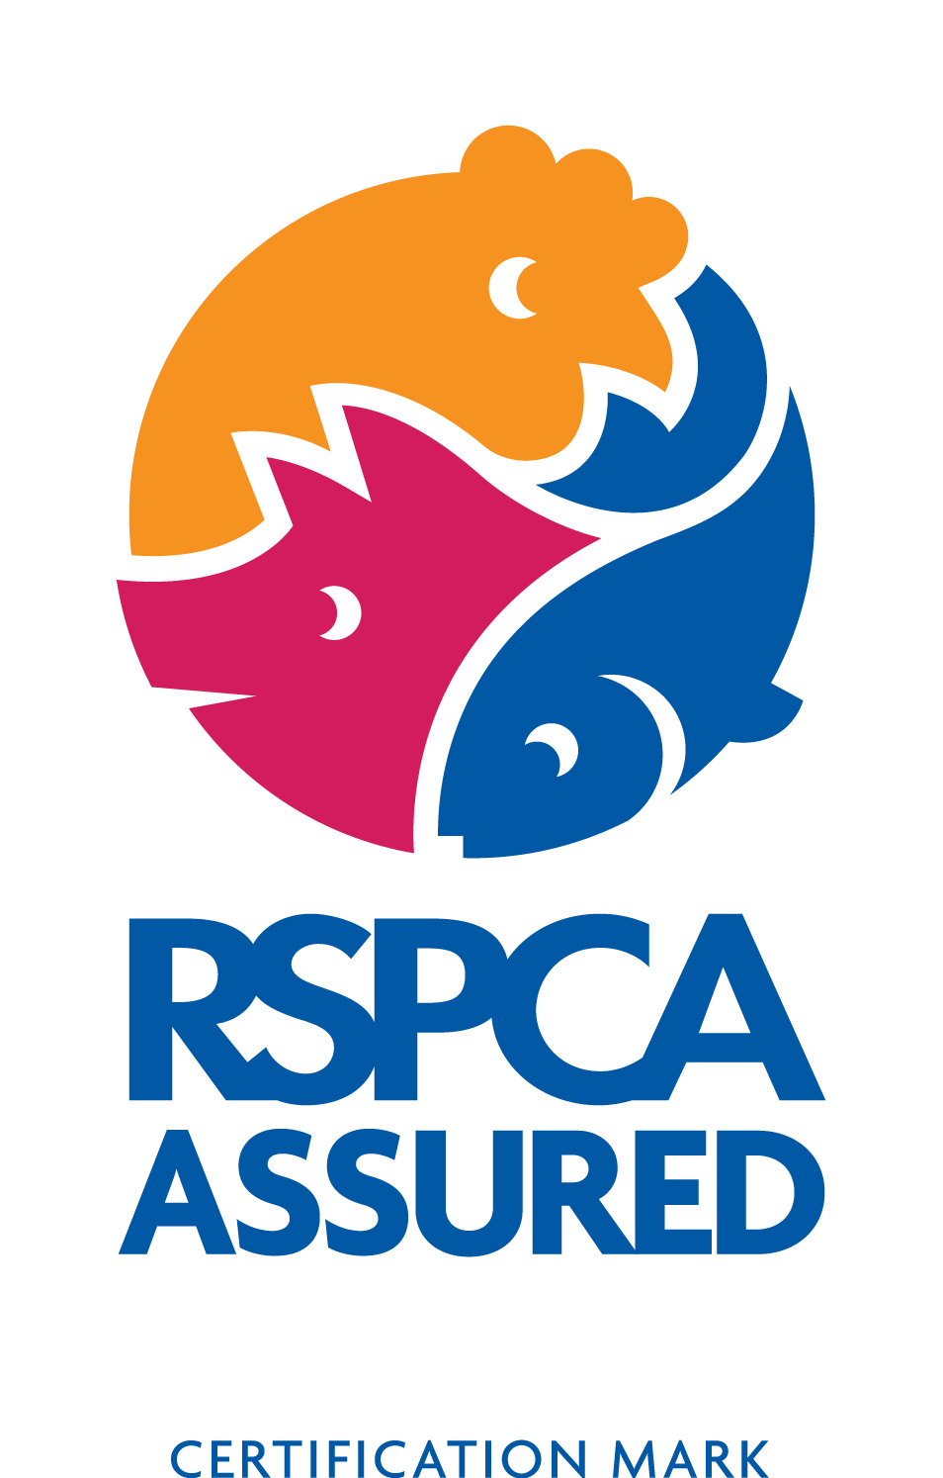
Teachers' notes – Happy hens game: instructions 1

Teachers' notes – Happy hens game: instructions 2 and 3

What you need:
- An empty egg box per player
- One set of egg cut-outs (2) or (3) per player. For version 2, arrange all the eggs of the same colour into piles and place in the centre of the table.
- For version 3, arrange all the eggs with the same words into piles
- A ‘spinner A’ (mounted on card). Pierce the middle with a pencil and use this as a central point for spinning the card. A matchstick or dome-headed screw would also work well
- A ‘spinner B’ (as above)
- A spinner B key sheet

How to play:
- Play the game in small groups of no more than six players.
- The first player turns spinner A. If it lands on the caged hen, pass it to the next player. If it lands on the free-range hen, the first player can then turn spinner B.
- When the spinner has landed on a symbol, the player has to guess what the symbol means and choose the egg with the correct description. For example, if the spinner lands on the yellow house symbol, the player would pick up the egg that says "a comfortable place to live". They can use the spinner key to see if they are right.
- The player places the egg in their egg box. If they already have one of these eggs, they put the egg back into the pile and it is the next player’s turn.
- If the spinner lands on the RSPCA Assured logo, the player picks up the egg with this symbol OR any other egg that they need.
- The winner is the first player to fill their box with the six different free-range eggs.

