In this lesson, pupils will look at what animals need to stay healthy and happy.

Curriculum objectives
Pupils should learn:
- that all humans have needs
- that all animals have needs
- in group discussions, to take different views into account while developing their ideas.

Learning outcomes
At the end of this lesson:
- most pupils: know that animals have needs just like humans, and that these needs include food, water, companionship, a suitable place to live, being looked after by a vet if they are ill, and the freedom to express normal behaviour
- some pupils have not made so much progress and: know that animals have needs like humans
- some pupils have progressed further and: know that animals have needs just like humans, and that these needs include food, water, companionship, a suitable place to live, being looked after by a vet if they are ill, and the freedom to express normal behaviour. They begin to appreciate the ways in which humans have a responsibility towards all animals - wild animals, farm animals and pets.

Starter activity
Humans want
- Ask pupils to think, for two minutes, about what makes them happy. Ask everyone in the class to make a suggestion. Write or draw all the answers on the board. Repeat this, asking pupils to think what makes them healthy.
- If pupils are enthusiastic and want to do some more reading or research - you could extend this as a homework activity. Most of their answers will probably relate to things that they would like to have in their lives.
Learning styles: auditory.

Main activity
What humans need
- Explain that they are now going to think about what they really need. Working in small groups, ask pupils to look at the list on the board and pick out which answers they think are basic needs, rather than things that they like or enjoy. They can add ideas to their lists if they think of something that hasn't been mentioned. Groups should limit their lists to no more than eight items.
- Come back together as a class and discuss the lists. Try to agree on a set of basic human needs and write or draw these on the board or flipchart.
Animals need
- Pupils should now think about what animals need to be happy and healthy. Some of them will have pets or know about farm animals or wildlife and can suggest ideas; others may need more guidance. Refer to factsheet The five freedoms and the Pet care section of the RSPCA website (see Useful websites tab). Ask pupils to suggest things that they think animals need. It may help to talk about a specific animal that they have experience of, such as a pet or farm animal. They can write or draw their answers on the worksheet What do they need?. You could enlarge this worksheet onto A3 paper for some pupils.
- For differentiation, you could play 'Pass the pebble', in a circle. Each pupil has to say what makes them happy or healthy when they are holding the pebble. Then put a soft toy animal in the centre of the circle and ask them what makes it happy and healthy. Are any of the things the same?
Compare and contrast
Compare the two lists of needs you have written and discuss. Pupils should realise that the lists are similar.

Different needs
- Depending on the class ability, you may be able to put together separate lists of needs for pets, farm animals and wildlife. Again, make sure that pupils understand the difference between 'wants' and 'needs'. Write this list on the board, next to the list you prepared for humans.
- The following differentiation activity could be used to consolidate what pupils have learned in the list-making activities. It is also suitable for pupils who find it difficult to think of needs of their own:
- On a table, lay out some pictures of animals (see Pets Image collection) and the type of things that they might need, for example: food, a brush for grooming, water and other animals for company. You can also include 'wild card' images, such as a bar of chocolate, a cup of coffee and a bicycle, to get pupils thinking.
- Ask them to choose an animal and draw it in the centre of an A3 sheet of paper. They can choose things that they think it needs and draw them around the edge. (Alternatively, pupils can cut out and glue the pictures). Encourage pupils to write what each need is, next to the picture.
Learning styles: visual, auditory, kinaesthetic.

Plenary activity
Looking back and forward
Ask pupils what they have learned from the activity. How did they feel thinking about animal needs? Is there anything they will do differently as a result?
Learning styles: auditory, kinaesthetic.

Assessment
Plenary - review and discussion of work covered.

Extension activities
- Show pupils images of animals from Aardman Animations' Creature Comforts (see Useful websites tab). Explain that the animals have been interviewed to find out what they need.
- Working in pairs or small groups, the pupils should imagine that they are going to interview the animals.
What questions would they like to ask?
- The answers should be recorded on the worksheets What would the animals say? and What would you like to ask the animals? in the form of a conversation. So they would write their question, followed by the animal's answer.
- Encourage them to act out the interviews in front of the rest of the class, some pupils playing the part of the animals and some playing the part of the interviewers - then swap roles. (This could form the basis of a class assembly on animal welfare - pupils could begin with role play and then go on to explain more about how we should all look after animals and about the work of the RSPCA).

ICT
Using a drawing program, pupils can design and create a What do animals need? poster. They could use photos of their pets, or of animals that they particularly like, and add their own text.

Did you know?
- It costs around £700 a year in the UK to keep an average-sized dog.
- More than 900 million farm animals are produced every year in the UK.
- RSPCA Assured is the RSPCA's farm assurance and food labelling scheme. Formerly known as Freedom Food, it was set up in 1994. It aims to improve the lives of as many farm animals as possible.

Vocabulary
byw / alive gofal / careanifeiliaid fferm / farm animals iachus / healthy
living cyfrifoldebau / responsibilities anghenion / needs hawliau / rights anifeiliaid anwes / pets dymuniadau / wants
lles / welfare cyfrifoldebau / responsibilities rheolau / rules
bywyd gwyllt / wildlife

Useful websites
Free images packs
RSPCA - All about animals - General pet care
RSPCA - Science group
RSPCA Assured
RSPCA - About us
Aardman Animations - Creature Comforts

Factsheets - The five freedoms

The five freedoms are like a wish list for animals. The RSPCA believes that anyone who looks after an animal should try to give them the five freedoms:

- Freedom from hunger and thirst
by providing enough fresh water and the right type and amount of food to keep them fit.
- Freedom from discomfort
by making sure that animals have the right type of environment including shelter and somewhere comfortable to rest.
- Freedom from pain, injury and disease
by preventing them from getting ill or injured and by making sure animals are diagnosed and treated rapidly if they do.
- Freedom to express normal behaviour
by making sure animals have enough space, proper facilities and the company of other animals of their own kind.
- Freedom from fear and distress
by making sure their conditions and treatment avoid mental suffering.

Teachers – find out more in the Did you know? section of the lesson resource.
Factsheets - Y pum rhyddid

Mae’r pum rhyddid yn fath o lythyr Siôn Corn i anifeiliaid. Mae’r RSPCA yn credu y dylai pawb sy’n gofalu am anifeiliaid geisio rhoi’r pum rhyddid iddynt:

- Rhyddid rhag newyn a syched
trwy roi digon o ddwˆ r ffres a digon, ond nid gormod, o’r bwyd iawn iddynt i’w cadw’n iach.
- Rhyddid rhag anghysur
trwy wneud yn siwˆ r bod yr anifeiliaid yn cael y math iawn o amgylchedd gan gynnwys cysgod a rhywle cysurus i orffwys.
- Rhyddid rhag poen, anaf a chlefydau
trwy eu hatal rhag mynd yn sâl neu gael eu hanafu a thrwy wneud yn siwˆ r bod anifeiliaid yn cael diagnosis a thriniaeth yn gyflym os yw hynny’n digwydd.
- Rhyddid i ymddwyn yn naturiol
trwy wneud yn siwˆ r bod gan anifeiliaid ddigon o le, cyfleusterau cywir a chwmni anifeiliaid eraill yr un fath â nhw.
- Rhyddid rhag ofn a gofid
trwy wneud yn siwˆ r bod eu hamgylchiadau a’r driniaeth a gânt yn osgoi dioddef meddyliol.

Athrawon – cewch ragor o wybodaeth yn yr adran Wyddech chi? yn adnoddau’r wers.
Worksheet - What do they need?

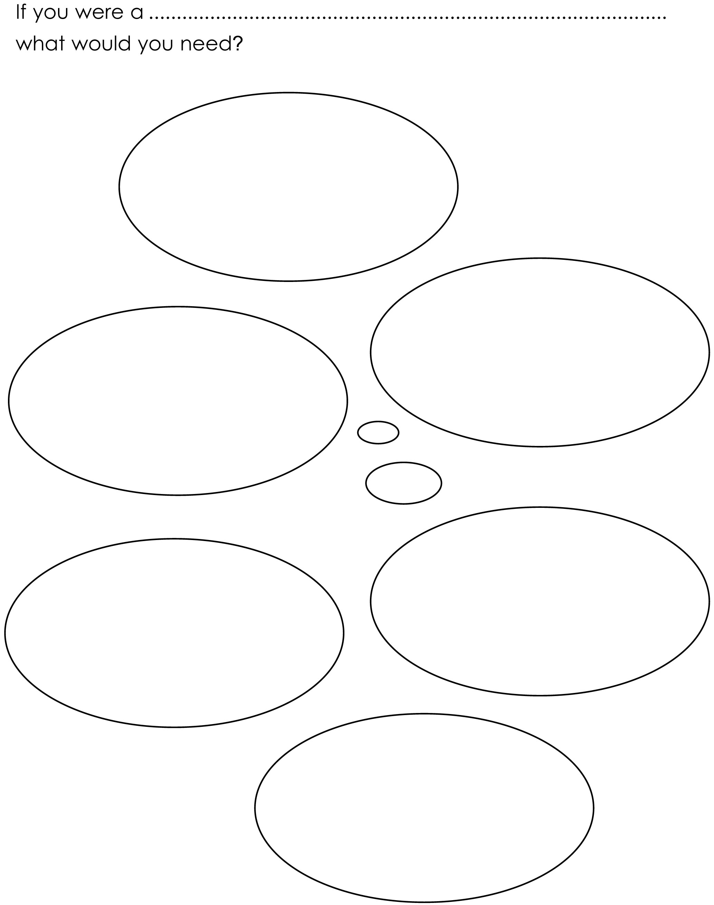

Worksheet - WS Beth yw eu hanghenion

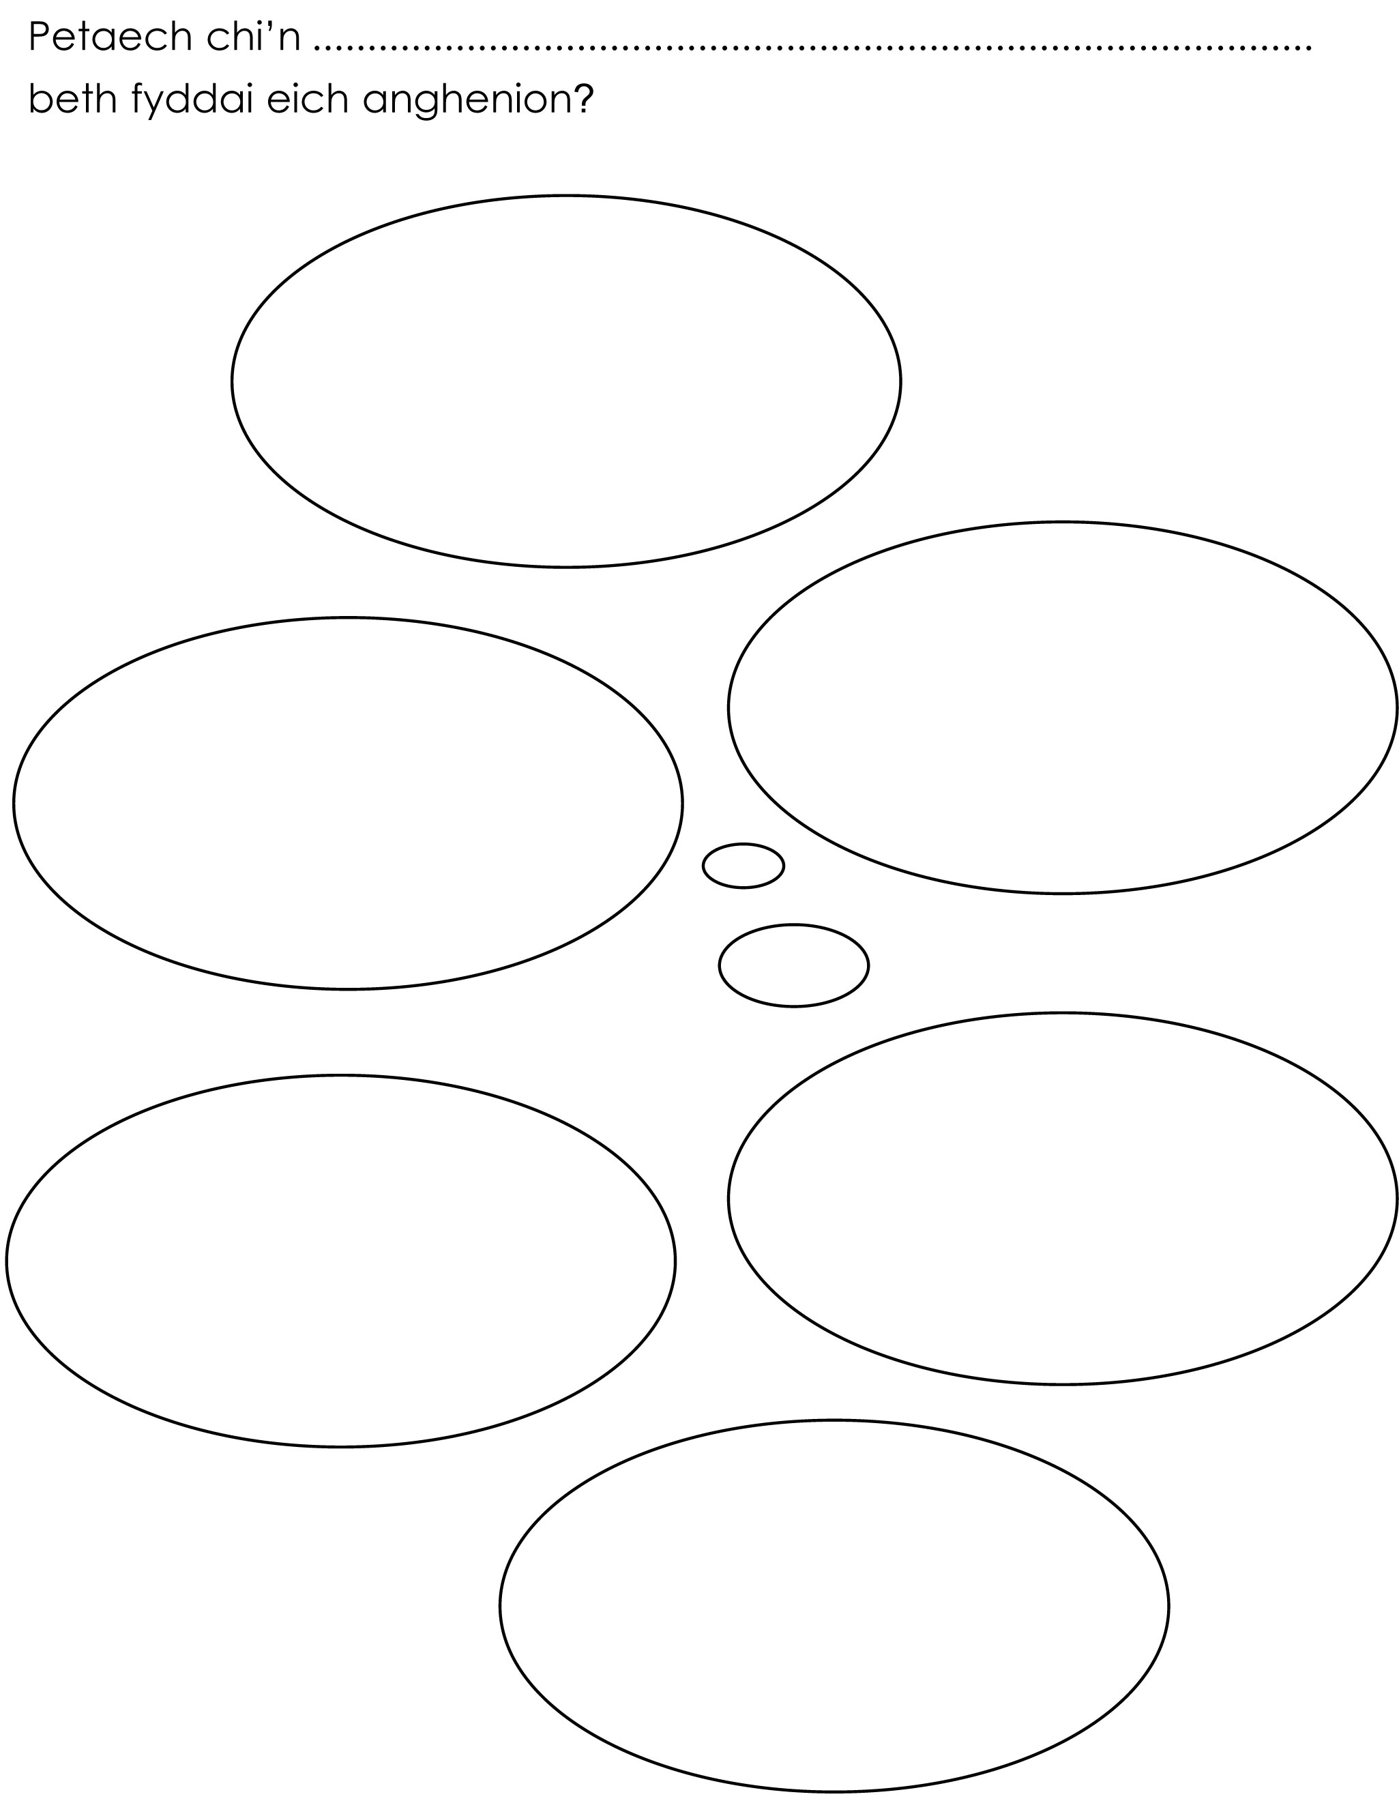
Worksheet - What would the animals say?

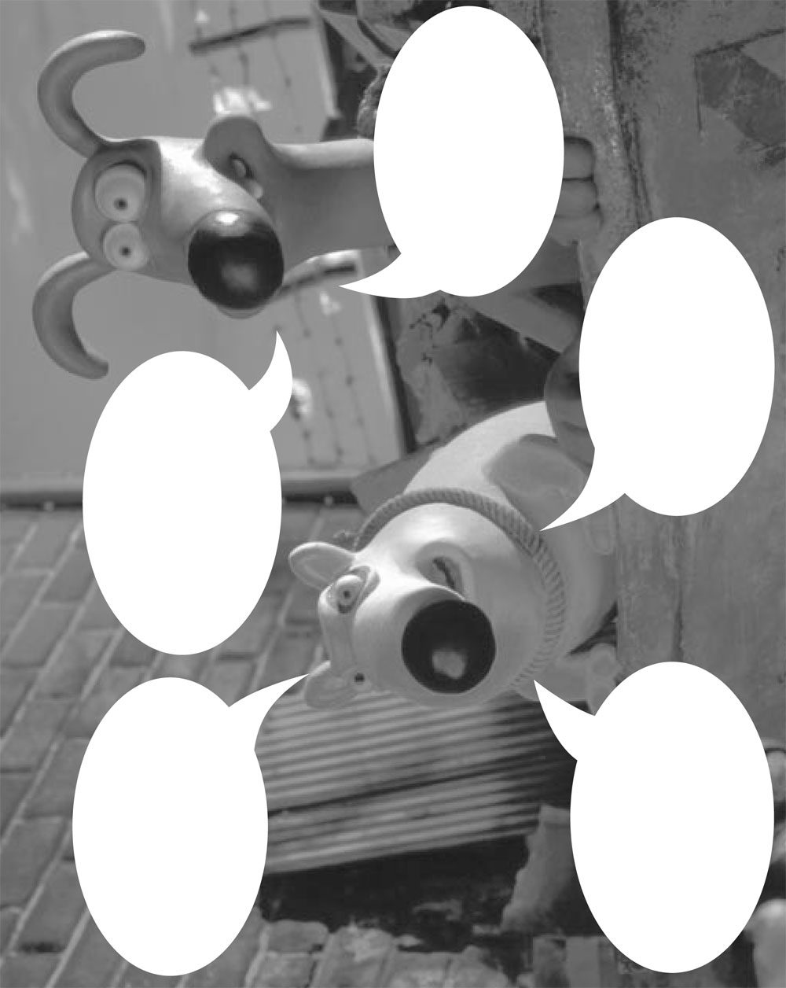
Worksheet - Beth fyddai'r anifeiliaid yn ei ddweud

Worksheet - What would you like to ask the animals?

Worksheet - Beth hoffech chi ei ofyn i'r anifeiliaid?

