This activity uses role play to explore the role of agencies in encouraging people to become responsible pet owners, with a focus on non-domestic exotic animals. This session could follow Dogs and the law. This lesson only applies to legislation in England.

Starter activity
Meeting pets' needs
- Students complete the quiz Pets and the law.
- Ask the students to consider what all pets need. Introduce the five welfare needs as defined in the Animal Welfare Act 2006 (see factsheet and teachers' notes).
- Show the class images of pets from the image collection attached to this resource. Ask them to place these in order from 'easiest to meet its needs' to 'hardest to meet its needs'.
- Introduce students to the pet care information on the RSPCA website (RSPCA – advice and welfare of pets in Useful websites) and ask them to revisit the order of pets.
Learning styles: visual, auditory.

Main activity
Animal welfare forum
- Read the factsheet Big cat in Peckham! and the RSPCA statement, and discuss the issues.
- Read the factsheet Non-domestic (exotic) pets.
- Set up the scenario that there is a local problem with people buying non-domestic pets and then struggling to meet their needs. A number of young people are buying non-domestic pets but they don't always have the knowledge, time and money to care for them properly. Also, some of them are under 16 and are too young to legally buy a pet. The local authority and the RSPCA are having to rescue and rehome a number of animals. The main issue is that people don't know or understand their responsibilities under the Animal Welfare Act 2006 (see The Animal Welfare Act 2006 factsheet and teachers' notes for more information).
- It has been decided that a local forum will be set up to address the problem.
- Using the role play cards, students form five expert groups that will send a representative to the forum. These are:
- RSPCA
- Environmental services officer
- Owner of an iguana
- Breeder of non-domestic (exotic) animals
- Local person who will act as chairperson.
- Groups discuss the issue from their point of view. They decide what they will contribute to the forum.
- Regroup to form several mixed forums.
- Using the Animal welfare forum agenda, the chairperson runs the role play. The forum creates an action plan to resolve the issue.
- Groups present their action plan to the class.
Learning styles: auditory, kinaesthetic.

Plenary activity
What do you think?
- Who do the students think is responsible for ensuring the needs of pets are met? Why?
- What measures would they put in place to ensure that only those people who were able to provide the care that pets need were able to purchase them? Would these measures require a new law or do the students think these can be achieved using alternatives methods, for example, a voluntary code of practice? A voluntary code of practice is a set of guidelines that organisations choose to sign up to, but it is not compulsory for all.
Learning styles: auditory.

Assessment
Portfolio opportunities:
- Research notes for the role play.
Assessment questions:
- What questions did I want to find out more about?
- How did I find the answers?
- How did I judge the information I found?

Extension activities
- Could you set up an animal welfare forum for animal welfare issues in the school? Perhaps it could be part of the school council?
- Students could research online pet shops and what information, if any, they provide on the animals' needs.

Did you know?
- The Born Free Foundation reported that in 2006, there were known to be at least 154 big cats held in private hands (including 12 lions and 14 tigers), almost 500 assorted monkeys, over 250 venomous snakes and 50 members of the crocodile family in the UK.
- A study conducted by The Queen's University of Belfast for the RSPCA in 2002 found that lizards are the most popular species of 'exotic' animal accounting for 28.9 per cent of all 'exotic' animals kept.
- Between 2000 and 2004, the RSPCA rescued 3,135 lizards and 42 alligators and crocodiles.
- Between 1994 and 2004, the European Union was one of the largest importers of wild-caught birds. It imported a massive 9.5 million birds of species listed in the appendices of the Convention on International Trade in Endangered Species (CITES) of wild fauna and flora - equivalent to 87 per cent of the world trade. However, as a result of the avian influenza outbreak and campaigning by the RSPCA, RSPB, APA and others, there is now a permanent ban on the import of wild birds into Britain and the rest of the European Union.
- Few reptile species are bred regularly on a large commercial scale in the UK. Most green iguanas are imported as hatchlings from countries in South America, Africa and Indonesia. However, many breeders are able to support their hobby by breeding and selling the young of many other species.

Curriculum objectives
Students should learn:
- to consider the part people play in creating social pressure, both individually and by joining together.

Animal welfare objectives
Students should learn:
- about the welfare issues involved in keeping pets
- about the role of agencies and the law in promoting responsible pet ownership.

Learning outcomes
At the end of this session:
- most students: have an understanding of the welfare needs of pets and whose responsibility it is to ensure that these are met. They identify and describe ways in which individuals and groups outside parliament can influence legislation
- some students have not made so much progress and: understand that pets have needs and that different people have different views on the issue of animal welfare
- some students have progressed further and: have a good understanding of the needs of a number of different pets and are able to explain who they think is responsible for meeting these needs. They understand how public opinion and the media, as well as lobby and voluntary organisations and groups, can influence decision-making. They research and discuss the issues raised, present their ideas and reflect on their opinions and those of others.

Vocabulary
agencies forum exotic legislation local authority
responsible pet ownership

Useful websites
RSPCA - Advice and welfare of pets
RSPCA - Cyberpet mobidog
RSPCA report - Far from home
Defra - Animal Welfare Act
Defra - Protecting pets from cruelty
Write To Them
APA - Animal Protection Agency
Born Free Foundation
Dangerous Wild Animals Act 1976
Keeping a wild animal - licensing
Images – Non-domestic (exotic) pet – Iguana

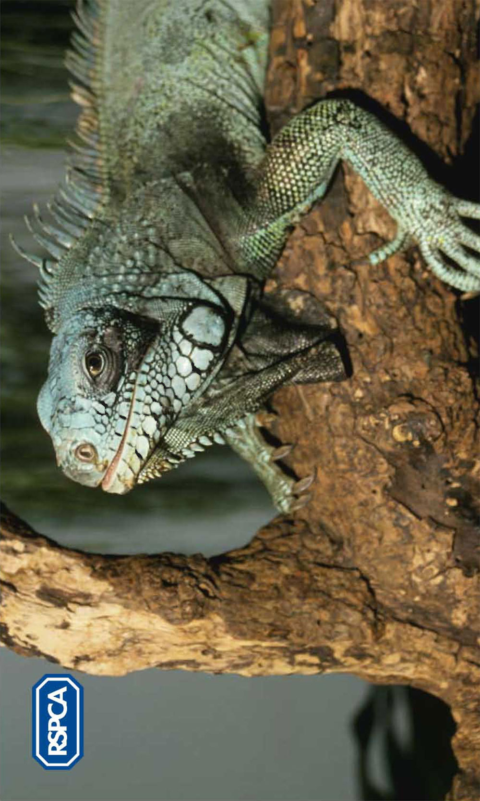

Worksheet – Pets and the law - role play cards

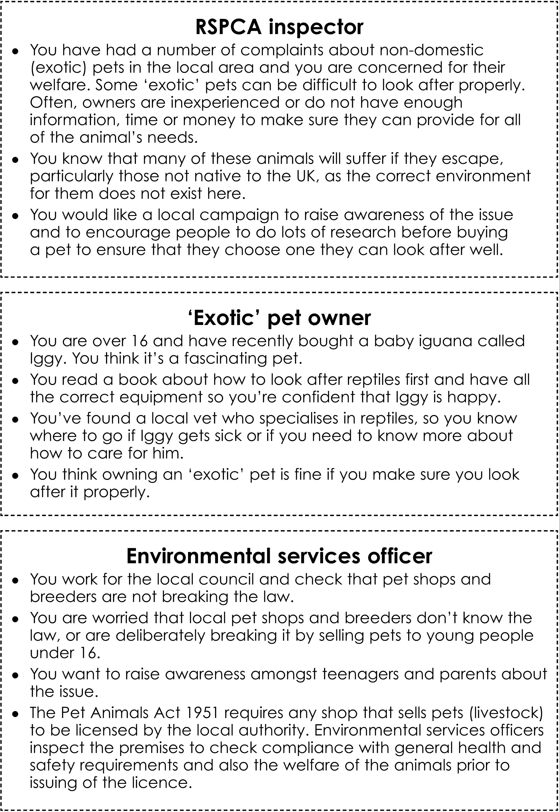
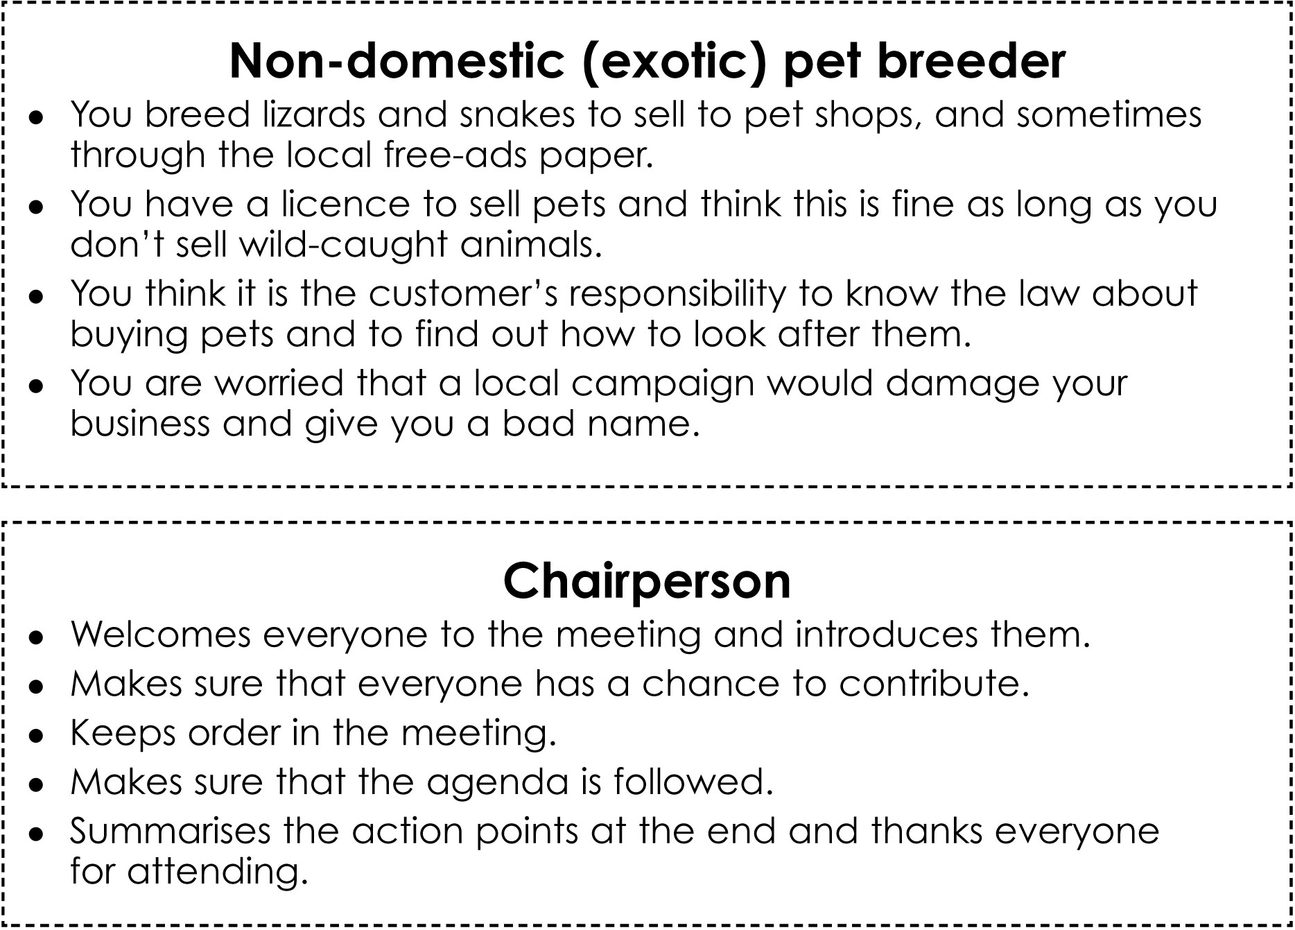

Factsheet – The Animal Welfare Act 2006

The Animal Welfare Act 2006 protects vertebrate animals (those with a backbone) that don’t live in the wild, e.g. pets and animals in circuses and zoos.
The offences in the Act are divided into two broad categories – the promotion of animal welfare and the prevention of harm to animals.

The promotion of animal welfare

Duty of care
Any person responsible for an animal must take reasonable steps to make sure the animal’s welfare needs are met (in line with good practice). These needs include:

- a suitable place to live
- suitable food and water
- to be able to behave normally
- to be with other animals or alone – whatever suits that type of animal, and
- to be protected from pain, suffering, injury and disease.

You may notice that these needs are very similar to the five freedoms, mentioned in other RSPCA education resources.

Only the courts can decide what ‘good practice’ means in relation to looking after different animals.

The concept of good practice may change with time. For example, many people keep rabbits in hutches on their own, which is not illegal under the Animal Welfare Act. However, an increasing number of experts believe that rabbits are social animals that, in a natural state, live in groups, and that living alone does not fulfil their need to have the company of other animals.

Therefore, the courts may, in the future, decide on the basis of such advice that keeping a rabbit on its own is not ‘good practice’ and is therefore an offence.

Selling animals to persons under 16/offering animals as prizes
An animal cannot be sold or given to a person under 16.

The prevention of harm to animals

Unnecessary suffering
It is illegal to make an animal suffer unnecessarily or let someone else do so. For example, beating a dog.

Mutilation/docking of dogs’ tails
It is illegal to mutilate an animal’s body or cut off (dock) a dog’s tail, unless it is necessary for the animal’s medical treatment or it is specifically allowed (by regulations or by the vet). Different exceptions apply to dogs in England and Wales.

Administration of poisons
One example of an offence is leaving rat poison out, which may be eaten by another animal.

Fighting
It is illegal to make animals fight. It is also illegal to train an animal to fight, to receive money from someone who wants to watch your dog fight another animal, to bet on a fight or even go to a fight. Animals that are sometimes used for fighting are dogs, badgers and cockerels.

What happens if you break the law?
Some of the things that may happen if a court finds you guilty are:
- going to prison
- taking away an animal
- stopping someone from owning an animal
- fines of up to £20,000
- putting an animal to sleep.

How will the Animal Welfare Act develop in future?
Whilst the Animal Welfare Act provides general guidance for the protection of animals, the government intends to make more specific laws (secondary legislation) to cover particular situations or kinds of animals.

The Act has already been developed for:
- the keeping of dogs, cats and equines (horses, ponies and donkeys)
- racing greyhounds
- keeping non-human primates (e.g. monkeys and apes) as pets
- game birds.

Some examples of issues that could be covered in the next couple of years are:
- wild animals in circuses
- performing animals
- pet shops
- boarding establishments.

REMEMBER! If you think someone has broken the law, you should tell an adult or telephone the RSPCA on 0300 1234 999. You won’t have to give your name.

Factsheet – Pets and the law quiz

Circle one answer for each question:

- You can legally own a pet from the age of 10. True/False
- If you are looking after someone else’s pet, you are not legally responsible. True/False
- It is illegal to keep your cat inside all the time. True/False
- It is against the law to buy and sell endangered species. True/False
- By law, you must take your animal to the vet at least once a year. True/False
- Pet birds do not need to be able to fly in their cages. True/False
- Dog fighting is legal as long as you have a licence. True/False
- It is illegal to keep a rabbit in a hutch if it can’t sit up on its back legs. True/False
- It is illegal to give an animal as a prize to a child. True/False
- It is illegal to allow animals used in experiments to suffer. True/False

Answers
- False - under the Animal Welfare Act 2006, you can only legally own a pet from the age of 16.
- False - if you are temporarily in charge of an animal, you have a legal responsibility for it. However, if you are under 16, your parent or guardian is legally responsible for the animal.
- False - this is not illegal, as long as the animal's needs are being met and the cat is not showing signs of distress as a result of being confined. Most cats like to go outdoors but if the cat is able to express normal behaviour and has enough room to move around indoors, then it is OK to keep it inside.
- True - there are Customs and Excise regulations that prevent endangered species being imported. In the UK it is illegal to trade in certain endangered species.
- False - under the Animal Welfare Act 2006, as long as your animal is not suffering you do not need to take it to the vet regularly.
- True - it depends on the size of the bird and the size of the cage, and whether the bird's needs are being met inside the cage. It is only a legal requirement that birds kept in captivity have enough room (in all directions) to stretch their wings freely.
- False - all animal fighting is illegal. This includes training an animal to fight and being present at a fight.
- True - the Animal Welfare Act 2006 states that animals should be able to display natural behaviour. For rabbits, this includes being able to sit up.
- False - however, under 16s must be accompanied by an adult who must agree to accept the prize.
- False - there is no law specifically related to the suffering of animals used in research. However, all uses of animals in research must be licensed under the Animals (Scientific Procedures) Act 1986, which imposes strict conditions.

Factsheet – Non-domestic (exotic) pets

What is a non-domestic (exotic) pet?
The term ‘non-domestic’ or ‘exotic’ is difficult to define. Strictly speaking, it should relate to any animal kept outside of its country of origin. However, this would include rabbits, gerbils and hamsters, even though these animals have been bred and kept in captivity for a long time.

Non-domestic or exotic pets can be any animal:
- that is not well-established as a common household pet
- where limited and variable animal care information is available to pet owners
- where veterinary knowledge is not available from the majority of veterinary surgeries.

Which types of animals can be considered non-domestic (exotic)?
- Spiders, such as tarantulas
- Tropical frogs, toads, salamanders and newts
- Iguanas, geckos and chameleons
- Snakes
- Tortoises and terrapins
- Parrots, parakeets and other exotic birds
- Monkeys
- Chinchillas and chipmunks

Where do they come from?
A wide variety of animals are now bred in captivity in the UK.
However, every year, millions of wild animals continue to be trapped from countries such as South America and Africa for use in the pet trade. Many die at the time of capture, during transport and before being sold as pets. The trade in wild-caught ‘exotics’ for the pet trade, along with habitat destruction, means that several species, including parrots and tortoises, are now endangered.

What about the trade in endangered species?
CITES (Convention on International Trade in Endangered Species) is an international agreement designed to ensure that international trade in wild animals does not threaten their survival by preventing or restricting trade in certain endangered animals.

What do you need to consider when buying a non-domestic (exotic) pet?
Before you buy a non-domestic (exotic) animal or any other type of pet you should make sure that you have all the necessary equipment and enough time, money and commitment to provide the animal with a good standard of long-term care.

You should also find out as much as you can about how to look after that animal, particularly if it is a non-domestic pet, from your own research and from the pet seller. You will need to find out what veterinary care might be needed and whether your local vet can treat and give advice on non-domestic pets. Treating nondomestic pets can be expensive.

Many non-domestic pets are rescued by organisations such as the RSPCA, so consider rehoming a non-domestic pet rather than buying one. Although many non-domestic pets are now bred in the UK, some are captive-farmed in other countries and then imported, which is very stressful for the animal.

You should also make sure that you do not buy imported wild-caught animals.

Different animals have different needs, and some are more difficult to meet than others. It is important that owners choose the right animal for them.

Factsheet – RSPCA statement

February 2007

Dangerous wild animal licence for Peckham resident

A Peckham resident has been granted a licence to keep a clouded leopard in his garden. The decision, made by the local authority this week, was taken despite the fact that the man lives in a terraced house in a busy residential area.

The RSPCA has expressed concern about the decision and has called on the local authority to employ an inspector with experience in big cats to advise on the safety and animal welfare issues involved in this case. An RSPCA spokesperson explained that it would be very difficult to provide the leopard with a large enough enclosure and that the only justification for keeping such animals is for properly-managed breeding programmes designed to re-establish these endangered animals back into the wild.

The RSPCA is also concerned that the animal may escape. ‘If this happens, it would almost certainly have to be shot and killed and this process would cause the animal immense stress,’ said the spokesperson.

Factsheet – Big cat in Peckham!

Man can keep leopards in garden
© BBC News online
30/5/06

A conservationist has won the right to keep endangered wild animals in his garden in a residential area.

Todd Dalton was banned by Southwark Council from keeping a clouded leopard in a cage in Peckham, south London.

But Tower Bridge magistrates overturned the decision after a vet deemed the 3.6m (12ft) cages were “suitable” for the animals.

Neighbours had opposed Mr Dalton’s bid fearing the animals could escape and pose a threat to pets and even people.

Southwark Council said it was disappointed with the ruling.

Wild cats
“We do not agree with the law which says residents’ views cannot be taken into account when considering this type of licence,” a council spokesman said.

Mr Dalton will still require planning permission before he can use the cages to house the leopards and other wild cats, including an ocelot and a margay.

The council spokesman said residents would be consulted on Mr Dalton’s application for a change of use to his premises.

Mr Dalton, 30, set up an internet company selling exotic animal food such as green crocodile curry and snake vodka.

He said he was passionate about conservation and insisted the animals would be safe.

Factsheet – Animal welfare forum

Suggested agenda for the meeting

- Welcome from the chairperson.
- Each representative introduces himself or herself in turn and explains why he or she is there.
- What are the issues? Each representative contributes to this.
- What can be done? Agencies discuss possible ways in which they can work together to improve the situation.
- Chairperson makes a list of action points and appoints someone to carry them out.
- Chairperson concludes the meeting by thanking everyone for their time, and outlines the way forward.

Teachers’ notes – The Animal Welfare Act 2006

The Animal Welfare Act 2006 only applies to vertebrate, non-human animals (e.g. mammals, birds, reptiles, amphibians and fish).

The categories of animals protected by the Act depend on the offence in question.

Protected animals are those that are:
- commonly domesticated in the British Islands (e.g. dogs and cats, including feral cats and stray dogs), or
- under the control of man, whether on a permanent basis (e.g. wild animals in circuses and zoos) or a temporary basis (e.g. animals caught in traps), or
- not living in a wild state (e.g. animals that escape from captivity but cannot be described as living in a wild state because they are non-native to the British Islands).

The Act does not apply to invertebrates (e.g. insects, shellfish, octopuses and snails), foetal or embryonic animals, wild animals (that do not fall within the definition of protected animal) and research animals that are regulated by the Animals (Scientific Procedures) Act 1986.

The Act does not apply to the sea, only to inland waters (river, streams, lakes) and estuaries. The Act does not affect legal hunting (i.e. trail hunting), shooting and sea fishing, and does not apply to angling.

The offences in the Act are divided into two broad categories – the promotion of animal welfare and the prevention of harm to animals.

The owner of an animal is always considered to be legally ‘responsible’ for the animal’s welfare. But legal responsibility may also include the person who is in charge of an animal, even temporarily. If an animal is looked after by a child under 16, the person who has the care and control of the child (e.g. parent/guardian) is treated as responsible for the animal.

The promotion of animal welfare

Duty of care
A person commits an offence if he/she does not take reasonable steps to ensure that the needs of an animal for which he/she is responsible are met (the ‘duty of care’) in line with good practice (Only the courts are entitled to define what good practice means in relation to looking after different animals.).

The Act defines an animal’s needs as including:
- its need for a suitable environment
- its need for a suitable diet
- its need to be able to exhibit normal behaviour patterns
- any need it has to be housed with, or apart from, other animals, and
- its need to be protected from pain, suffering, injury and disease.
Selling animals to persons under 16
It is illegal to sell an animal to any person whom you have reasonable cause to believe to be under 16. This includes transferring or agreeing to transfer ownership of an animal (e.g. giving an unwanted pet to someone under 16).

Offering a person under 16 the chance to win an animal as a prize
Generally, it is an offence to offer a person under 16, who is not accompanied by an adult, an animal as a prize.

The prevention of harm to animals

Unnecessary suffering
There are two separate offences:
- to cause unnecessary suffering to a protected animal by an act (e.g. kicking a dog) or failure to act (e.g. to provide veterinary treatment)
- to permit unnecessary suffering to an animal for which that person is responsible, which has been caused by another person (e.g. allowing someone to neglect a pet by not feeding it).

Mutilation
Mutilation, i.e. interference with the sensitive tissues or bone structure of protected animals is banned unless:
- it is necessary for the animal’s medical treatment, or
- it is a procedure specifically allowed by regulations because it is performed in the animal’s long-term welfare interest or it is an accepted method of animal management, e.g. on farm.

Docking of dogs’ tails
It is illegal to dock a dog’s tail unless this is required for the purpose of its medical treatment or the dog is a certified working dog of a certain breed or breed type (as specified by secondary legislation) and is not more than five days old.
Different exceptions apply to dogs in England and Wales.

The showing of dogs with docked tails is also restricted. It is an offence to show a dog whose tail has been wholly or partially removed on or after 28 March 2007 (Wales) or 6 April 2007 (England) at an event that people pay money to watch. However, it is not illegal if the dog is a certified working dog and is shown only for the purposes of demonstrating its working ability.

Administration of poisons etc
A person commits an offence if they administer poisonous or injurious substances or drugs to a protected animal, or they permit someone else to do this. It also applies if they cause these substances to be taken by a protected animal, e.g. leaving rat poison out, which may be eaten by another animal.

Fighting etc
An animal fight is defined as an occasion on which a protected animal is placed with an animal or a human, for the purpose of fighting, wrestling or baiting.

There are a number of offences relating to animal fights. The main offences include causing an animal to fight, or attempting to do so, receiving money for admission to a fight, publicising a fight, training an animal to fight, betting on a fight and being present at an animal fight without lawful authority.

Animals commonly used for fighting include dogs, cockerels and badgers.

Sanctions
The magistrates have a range of sanctions available to them in the event of finding someone guilty of offences under the Act. Depending on the offence, these may include:
- custodial sentences of up to six months
- deprivation orders (taking the animal away)
- disqualification orders (banning a person from owning, keeping, controlling, influencing, dealing or transporting animals)
- fines of up to £20,000
- destruction of the animal.

Associated secondary legislation and codes of practice
The Animal Welfare Act has been designed to evolve over time and have a positive impact on attitudes to animals. Secondary legislation and codes of practice on the keeping of cats, dogs and equines, the rearing of game birds, racing greyhounds and keeping primates as pets have been published by the governments of England and Wales. Other secondary legislation on issues such as wild animals in circuses, performing animals and commercial pet vending may be introduced under the Act but will take a while to be written.

Until these are in place, any animal may be used for any purpose or activity, provided it is lawful (section 9.3). At times, this may appear to be in opposition to the welfare offence, for example, the suffering of battery hens. However, the standard to which the ‘duty of care’ applies is the extent required by ‘good practice’.

The concept of good practice is not static – it may evolve with time. For example, many people keep rabbits in hutches on their own, which is not illegal under the Act. However, an increasing number of experts believe that rabbits are social animals that, in a natural state, live in groups, and that living alone does not fulfil their need to have the company of other animals. Therefore, the courts may, in the future, decide on the basis of such advice that keeping a rabbit on its own is not ‘good practice’ and is therefore an offence.

Read more on secondary legislation and the Act for England and Wales.

The RSPCA is opposed to any activity involving animals that is likely to cause unnecessary suffering. If you believe an offence has been committed under the Animal Welfare Act
2006, you should telephone the RSPCA on 0300 1234 999.

