This lesson introduces the concept of cruelty to animals, with a focus on pets, and whether it is deliberate or based on neglect.

Starter activity
Types of cruelty
- Ask the pupils to think about cruelty to animals. What types of things do they think are cruel? Pupils often focus on deliberate cruelty - hitting and beating. Once they have been given a range of examples, ask them to think about the difference between:
- Deliberate cruelty - intending to do something that hurts an animal
- Neglect - failing to do something, which means that an animal suffers
- Not meeting an animal's needs - not providing an animal with the things it really needs.
- Do the pupils think one type of cruelty is worse than the other? Some pupils may feel that malice - deliberately wanting to hurt something - is worse than neglect. However, ask the pupils to think from an animal's point of view. All of these types of cruelty result in unnecessary suffering (see teachers' notes The Animal Welfare Act 2006).
Learning styles: auditory.

Main activity
Case studies
- Use the factsheet Animals in need as a focus. The case studies are based on real cases prosecuted by the RSPCA. They involve deliberate cruelty, neglect and not meeting the needs of an animal.
- Ask the groups of pupils to read through the factsheet. Each group could appoint a reader and leader.
- Ask the pupils to discuss each case study in turn and decide whether they think it is deliberate cruelty, neglect or not meeting an animal's needs.
- The answers are as follows:
- Lucky the puppy - deliberate cruelty
- Sadie the dog - neglect
- A full house - not meeting an animal's needs
Learning styles: visual, auditory.

Plenary activity
Helping animals
Having read and thought about the case studies - what would the pupils most like to change about the way some people treat animals? How would they like to help animals?
Learning styles: auditory.

Extension activities
Work through the pets flipcharts on the Promethean Planet website.

Did you know?
- In 2007 the law relating to the welfare of pets in England and Wales changed. Under the Animal Welfare Act anyone who is responsible for a pet now has a legal responsibility to meet the five basic welfare needs. These are:
  - A suitable place to live - Animals should have the right type of home, including shelter, enough space, and somewhere comfortable to rest and hide.
  - A healthy diet - Animals should have access to fresh, clean water all the time and should be given the right type and amount of food to keep them fit and healthy.
  - The ability to behave normally - Animals should have enough space and the right kind of facilities to allow them to behave normally.
  - The company he or she needs - Animals should be given appropriate company. Some animals should have company and some should be kept on their own.
  - To stay healthy - Animals should be protected from pain, suffering, injury and disease and should be treated by a vet if they are sick or injured.
- The Animal Welfare Act provides much greater protection for animals. Under the old law, people responsible for pets could only be prosecuted for cruelty once suffering had occurred, and when it was often too late to save the animal from death or lasting injury.
- A person commits the welfare offence if he/she does not take reasonable steps to ensure that the needs of an animal for which he/she is responsible are met.
- There are two separate offences relating to unnecessary suffering:
- to cause unnecessary suffering to an animal by an act or failure to act
- to permit unnecessary suffering to an animal for which that person is responsible, which has been caused by another person
- If a person is found guilty of offences under the Act, they may be subject to:
- custodial sentences of up to six months
- deprivation orders (taking the animal away)
- disqualification orders (banning a person from owning, keeping, controlling, influencing, dealing or transporting animals)
- fines of up to £20,000
- destruction of the animal
- Most of the cases seen by RSPCA inspectors are neglect caused by people who do not know how to look after animals properly. People don't understand how much time, effort and money are needed to care for their pets properly. Sadly, some people are also deliberately cruel to animals.
- Every 25 seconds, someone somewhere in England and Wales dials 0300 1234 999 - the RSPCA's national cruelty and advice line - for help.
- There were 153,770 complaints of cruelty investigated by our inspectors in 2013 which resulted in 3,961 convictions.

Vocabulary
cruelty deliberate neglect

Curriculum objectives
Pupils should learn:
- about the responsibilities humans have towards animals
- to know about the role of a national animal welfare organisation.

Learning outcomes
At the end of this lesson:
- most pupils: understand the role of voluntary organisations/charities. They know that we all have a responsibility towards animals, and that there are laws to protect them. They recognise that different pets have different needs, and that not everyone makes a suitable pet owner. They appreciate that there are a large number of animal welfare issues, and understand one in some depth. They contribute ideas and opinions to class discussions
- some pupils have not made so much progress and: understand the role of voluntary organisations/charities. They know that we all have a responsibility towards animals, and that there are laws to protect them. They recognise that different pets have different needs, and that not everyone makes a suitable pet owner. They appreciate that there are a large number of animal welfare issues
- some pupils have progressed further and: understand the role of voluntary organisations/charities and why we need them. They investigate a chosen voluntary/charitable organisation, and are aware of the breadth of its work. They know that we all have a responsibility towards animals, and that there are laws to protect them. They understand the need for such laws. They recognise that different pets have different needs, and that not everyone makes a suitable pet owner. They appreciate that there are a large number of animal welfare issues, and research one in some depth, understanding its complexity. They contribute ideas and opinions to class discussions.

Useful websites
RSPCA - All about animals - General pet care
RSPCA - Latest news
RSPCA - Careers
Defra - Animal Welfare Act
Pets flipcharts - Promethean Planet
Video - What do pets need?

Factsheet – Animals in need

People call the RSPCA when they are worried about the way an animal is being treated or if they think an animal is in danger. RSPCA inspectors go and see the animal to check it is happy and healthy.

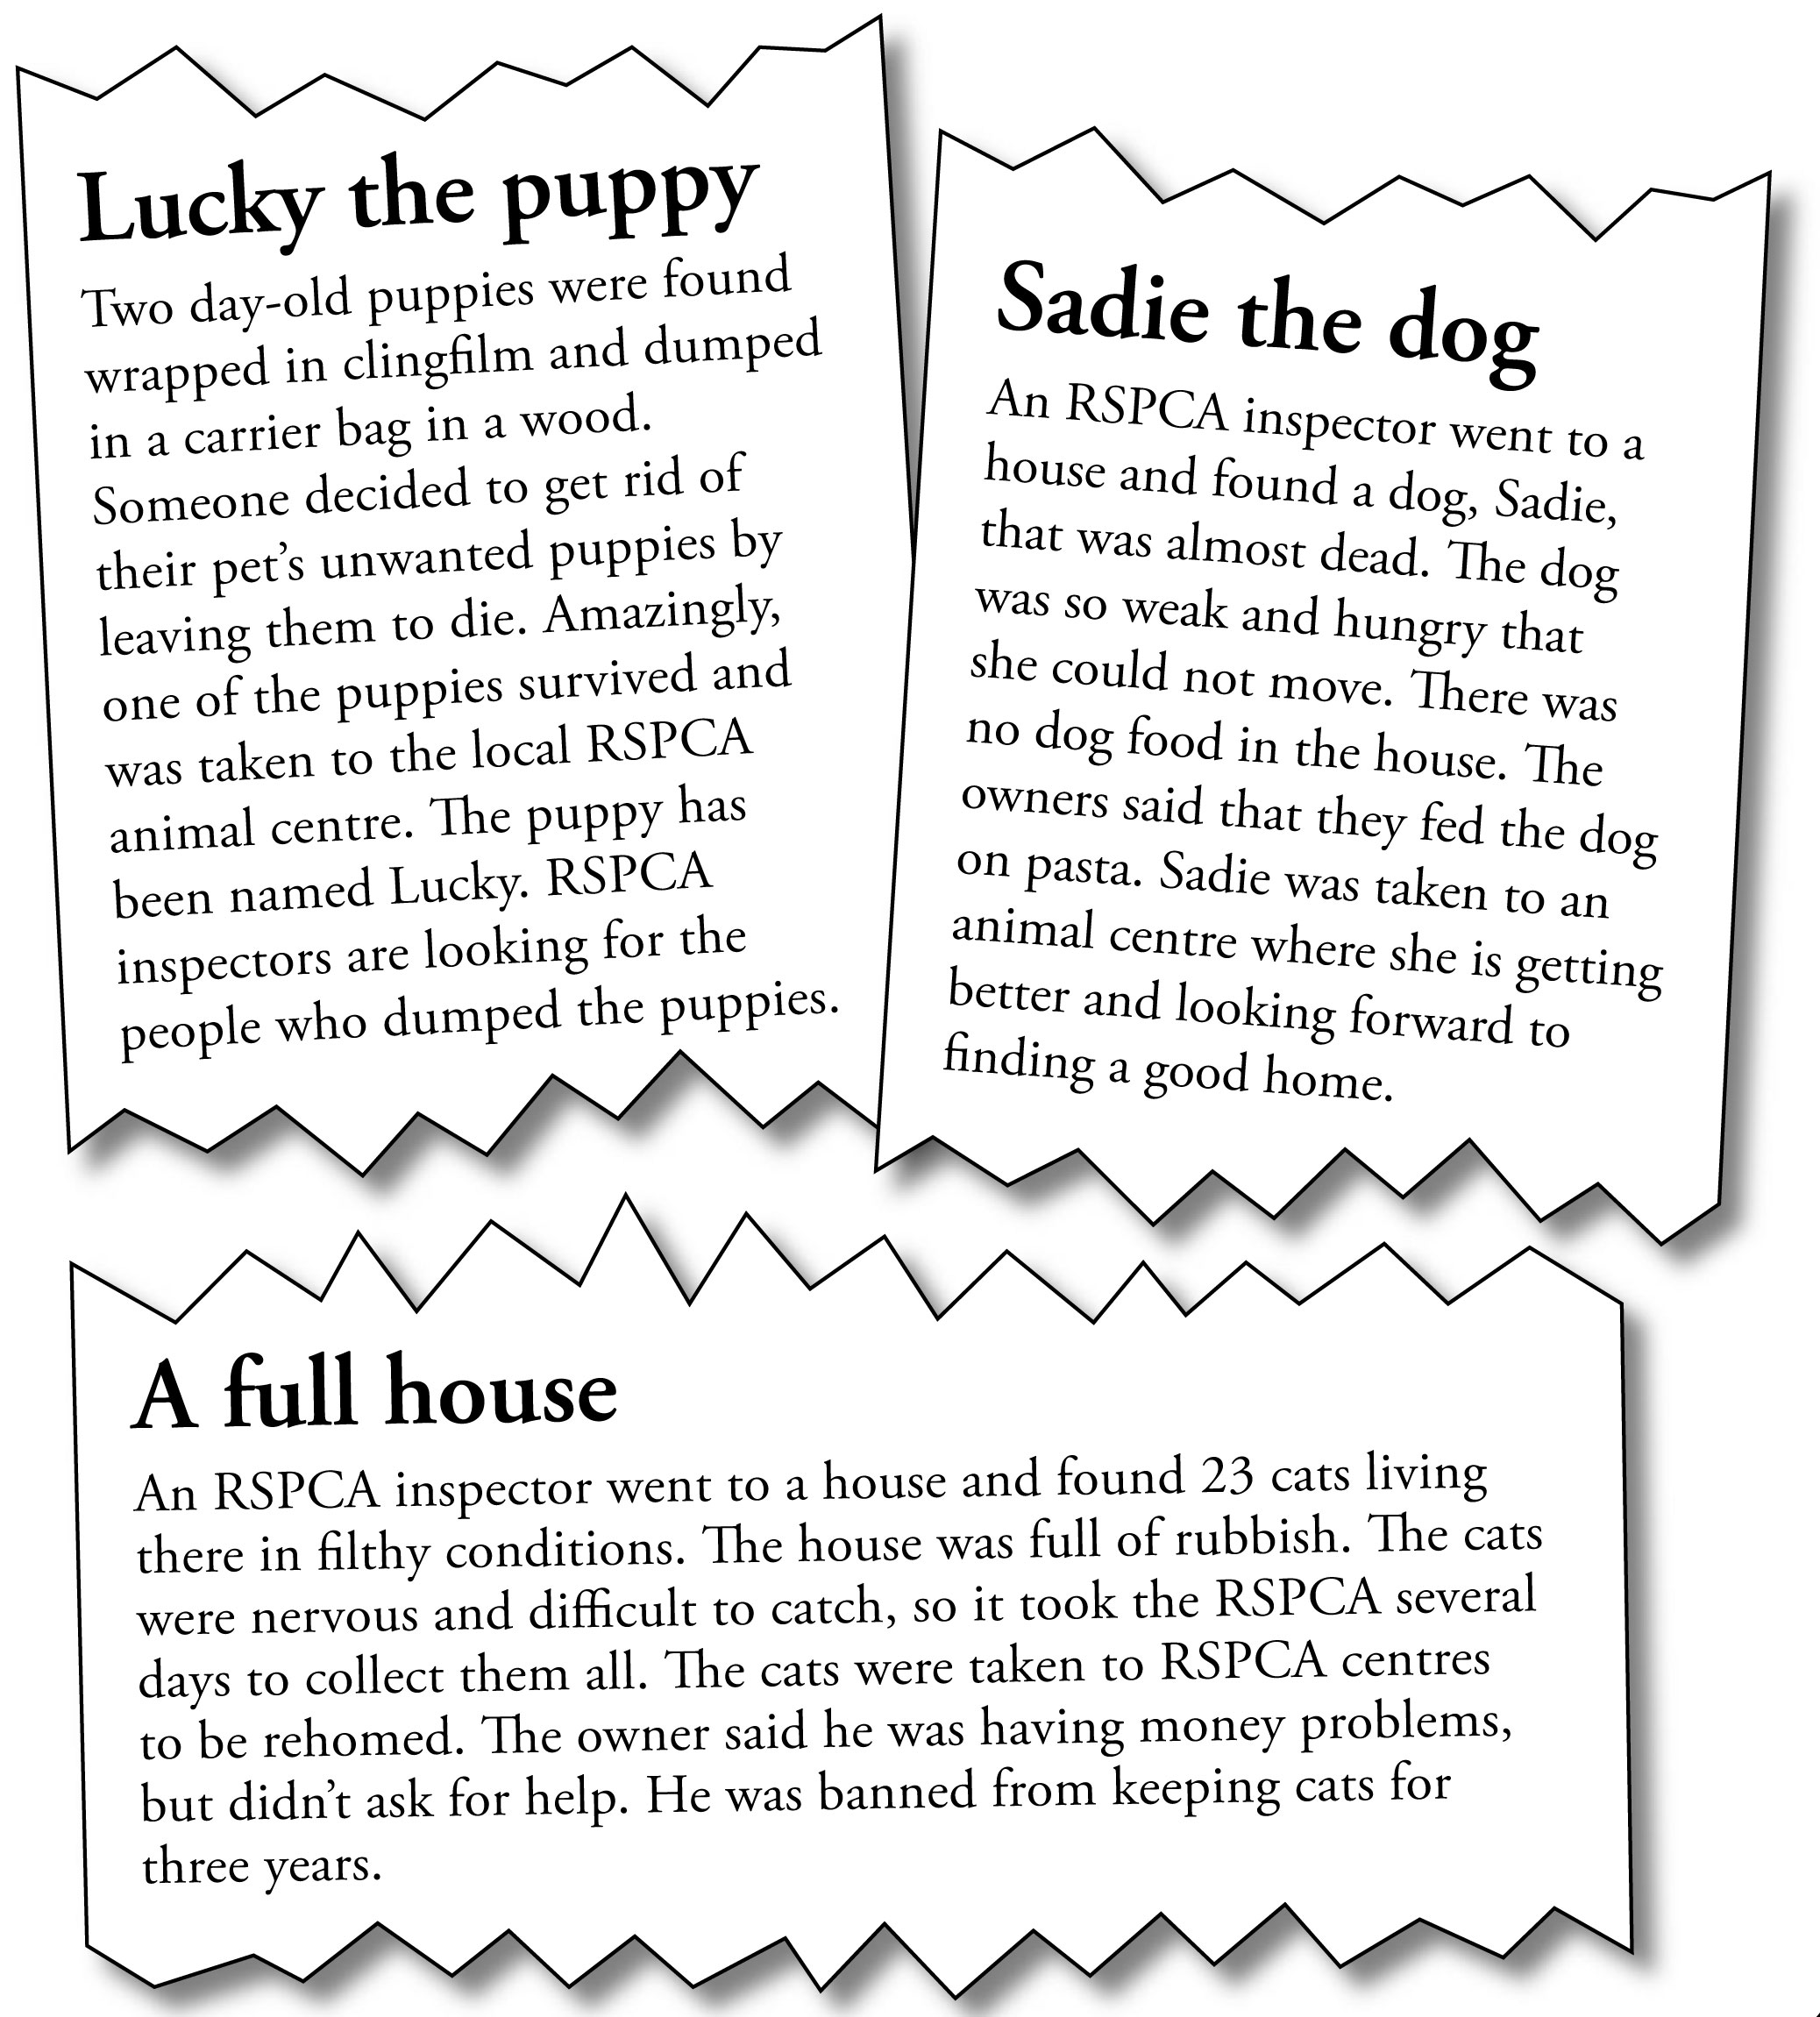
Teachers notes – The Animal Welfare Act 2006

The Animal Welfare Act 2006 only applies to vertebrate, non-human animals (e.g. mammals, birds, reptiles, amphibians and fish).

The categories of animals protected by the Act depend on the offence in question.

Protected animals are those that are:
- commonly domesticated in the British Islands (e.g. dogs and cats, including feral cats and stray dogs), or
- under the control of man, whether on a permanent basis (e.g. wild animals in circuses and zoos) or a temporary basis (e.g. animals caught in traps), or
- not living in a wild state (e.g. animals that escape from captivity but cannot be described as living in a wild state because they are non-native to the British Islands).

The Act does not apply to invertebrates (e.g. insects, shellfish, octopuses and snails), foetal or embryonic animals, wild animals (that do not fall within the definition of protected animal) and research animals that are regulated by the Animals (Scientific Procedures) Act 1986.

The Act does not apply to the sea, only to inland waters (river, streams, lakes) and estuaries. The Act does not affect legal hunting (i.e. trail hunting), shooting and sea fishing, and does not apply to angling.

The offences in the Act are divided into two broad categories – the promotion of animal welfare and the prevention of harm to animals.

The owner of an animal is always considered to be legally ‘responsible’ for the animal’s welfare. But legal responsibility may also include the person who is in charge of an animal, even temporarily. If an animal is looked after by a child under 16, the person who has the care and control of the child (e.g. parent/guardian) is treated as responsible for the animal.

The promotion of animal welfare

Duty of care
A person commits an offence if he/she does not take reasonable steps to ensure that the needs of an animal for which he/she is responsible are met (the ‘duty of care’) in line with good practice (Only the courts are entitled to define what good practice means in relation to looking after different animals).

The Act defines an animal’s needs as including:
- its need for a suitable environment
- its need for a suitable diet
- its need to be able to exhibit normal behaviour patterns
- any need it has to be housed with, or apart from, other animals, and
- its need to be protected from pain, suffering, injury and disease.

Selling animals to persons under 16
It is illegal to sell an animal to any person whom you have reasonable cause to believe to be under 16. This includes transferring or agreeing to transfer ownership of an animal (e.g. giving an unwanted pet to someone under 16).

Offering a person under 16 the chance to win an animal as a prize
Generally, it is an offence to offer a person under 16, who is not accompanied by an adult, an animal as a prize.

The prevention of harm to animals

Unnecessary suffering
There are two separate offences:
- to cause unnecessary suffering to a protected animal by an act (e.g. kicking a dog) or failure to act (e.g. to provide veterinary treatment)
- to permit unnecessary suffering to an animal for which that person is responsible, which has been caused by another person (e.g. allowing someone to neglect a pet by not feeding it).

Mutilation
Mutilation, i.e. interference with the sensitive tissues or bone structure of protected animals is banned unless:
- it is necessary for the animal’s medical treatment, or
- it is a procedure specifically allowed by regulations because it is performed in the animal’s long-term welfare interest or it is an accepted method of animal management, e.g. on farm.

Docking of dogs’ tails
It is illegal to dock a dog’s tail unless this is required for the purpose of its medical treatment or the dog is a certified working dog of a certain breed or breed type (as specified by secondary legislation) and is not more than five days old. Different exceptions apply to dogs in England and Wales.

The showing of dogs with docked tails is also restricted. It is an offence to show a dog whose tail has been wholly or partially removed on or after 28 March 2007 (Wales) or 6 April 2007 (England) at an event that people pay money to watch. However, it is not illegal if the dog is a certified working dog and is shown only for the purposes of demonstrating its working ability.

Administration of poisons etc
A person commits an offence if they administer poisonous or injurious substances or drugs to a protected animal, or they permit someone else to do this. It also applies if they cause these substances to be taken by a protected animal, e.g. leaving rat poison out, which may be eaten by another animal.

Fighting etc
An animal fight is defined as an occasion on which a protected animal is placed with an animal or a human, for the purpose of fighting, wrestling or baiting. There are a number of offences relating to animal fights. The main offences include causing an animal to fight, or attempting to do so, receiving money for admission to a fight, publicising a fight, training an animal to fight, betting on a fight and being present at an animal fight without lawful authority.

Animals commonly used for fighting include dogs, cockerels and badgers.

Sanctions
The magistrates have a range of sanctions available to them in the event of finding someone guilty of offences under the Act. Depending on the offence, these may include:
- custodial sentences of up to six months
- deprivation orders (taking the animal away)
- disqualification orders (banning a person from owning, keeping, controlling, influencing, dealing or transporting animals)
- fines of up to £20,000
- destruction of the animal.

Associated secondary legislation and codes of practice
The Animal Welfare Act has been designed to evolve over time and have a positive impact on attitudes to animals. Secondary legislation and codes of practice on the keeping of cats, dogs and equines, the rearing of game birds, racing greyhounds and keeping primates as pets have been published by the governments of England and Wales. Other secondary legislation on issues such as wild animals in circuses, performing animals and commercial pet vending may be introduced under the Act but will take a while to be written.

Until these are in place, any animal may be used for any purpose or activity, provided it is lawful (section 9.3). At times, this may appear to be in opposition to the welfare offence, for example, the suffering of battery hens. However, the standard to which the ‘duty of care’ applies is the extent required by ‘good practice’.

The concept of good practice is not static – it may evolve with time. For example, many people keep rabbits in hutches on their own, which is not illegal under the Act. However, an increasing number of experts believe that rabbits are social animals that, in a natural state, live in groups, and that living alone does not fulfil their need to have the company of other animals. Therefore, the courts may, in the future, decide on the basis of such advice that keeping a rabbit on its own is not ‘good practice’ and is therefore an offence.

Up-to-date information on secondary legislation and the Act for England
Up-to-date information on secondary legislation and the Act for Wales

The RSPCA is opposed to any activity involving animals that is likely to cause unnecessary suffering. If you believe an offence has been committed under the Animal Welfare Act
2006, you should report it online or call 0300 1234 999.

