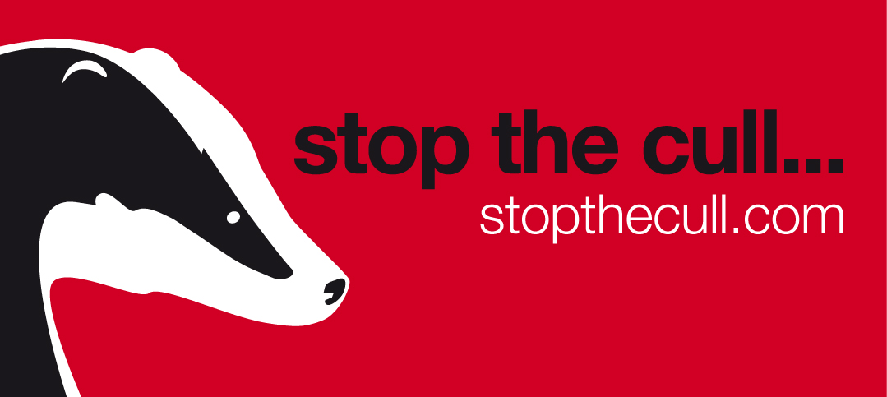
‘Stop the Cull’ campaign – Q&A
- Which organisations are involved in the ‘Stop the Cull’ campaign and why did you decide to form?
The -Stop the -Cull campaign is a coalition of organisations who have teamed up to fight the planned cull of badgers. The coalition consists of the RSPCA, League Against Cruel Sports, Humane Society International/UK and Save Me. We are united in our opposition to government plans to cull badgers in a misguided attempt to control the spread of bovineTB. If the badger cull does go ahead as planned at least 70% of the badger population in large areas of the country will be killed, many of them healthy. We simply cannot let that happen.
- What is your position on the planned cull of badgers?
A scientifically robust trial of badger culling was undertaken which took nearly a decade, cost approx £50million and the lives of 11,000 badgers. Following careful evaluation of the results, and information from other areas, the Independent Scientific Group concluded ‘badger culling can make no meaningful contribution to cattle TB control in Britain’, and indeed, suggests that such action could even make things worse in some areas. Even Defra's own advisory body Natural England, has said that it has little confidence in the cull delivering the predicted benefits long term. We believe that a cull of badgers will not eradicate TB in cattle in the long term and could virtually wipe out badgers in some areas in the process.
- If not a cull, then what is the best way to deal with bovineTB?
This cull will contribute little or nothing to the long-term goal of eradicating TB nationally. We believe that vaccination of cattle and/or badgers, increased levels of testing, improved biosecurity and stricter controls on the movement of cattle are better ways of eradicating bovine TB for good. Our opposition to a badger cull is based on solid science, not sentiment.
- What are the details of the planned culls?
There will initially be pilot culls in two areas of England in West Somerset and West Gloucestershire, though the exact parameters of the culls will not be made public. These ‘pilots’ are supposedly designed to assess the effectiveness and humaneness of culling badgers by free shooting. Importantly, they will not assess the effectiveness of culling as a control of the spread of the disease.
The culls will be paid for and undertaken by or on behalf of farmers who have been invited to put in an application for a licence to free-shoot badgers to Natural England, the body who will assess against certain criteria. It is currently unclear how badger wounding rates will be assessed and monitored.

The pilot culls are due to begin at any point after mid September.

- Do you have a position on the ‘free-shooting’ of badgers?
The humaneness of using the free-shooting method is of grave concern to the group. If a cull is to be carried out, we believe it should be done in the most humane way possible. Because of their anatomy it is potentially more difficult to free-shoot a badger in a quick humane way than, say a fox or a deer. This means there may be a high risk of wounding badgers instead of killing them outright, resulting in a slow, painful death for the animals. It is currently unclear how wounding rates will be assessed and monitored.

We also have concern surrounding draft guidance that dogs may be used to retrieve wounded animals. The legal protection provided to badgers was not just to safeguard badgers against the cruelty and persecution inflicted by badger diggers and baiters, (baiting is an activity which involves setting dogs upon badgers in order to encourage a fight between them), but also abuse by some farmers and landowners from activities such as bulldozing and slurrying badger setts. Whilst badgers can be legally killed and dogs used against them in the trial areas the same animals would be protected outside the trial areas leading to confusion on their status.

- If this is a choice between badgers suffering and cows suffering, then how do you justify saving badgers to the detriment of cows?
We believe that the public have been falsely presented with the choice between killing badgers and cows suffering. Killing badgers will not solve the problem of TB in cattle.

We are of course concerned deeply with the welfare of cows and remain committed to a long term solution to tackling the welfare issues associated with bTB infection in cattle.

However, we must point out that only a tiny minority of cattle who are killed upon a reaction to the bTB test show any clinical signs of the disease and do not suffer as a result of bTB. In reality vastly more dairy cattle in the UK suffer significant pain and discomfort from lameness and mastitis every year, with large numbers also being culled as a result of these common conditions.

To say the group is more concerned with saving badgers, to the detriment of the welfare of dairy cows is a flawed accusation.

- What happened to the planned vaccination programme?
An injectable Badger BCG vaccine was licensed by the Veterinary Medicines Directorate in March 2010, research is continuing regarding a possible oral vaccine.
In a government funded project nearly 1,200 badgers have so far been vaccinated in one area of Gloucestershire. The original plan was for badger vaccination to be undertaken in six large areas but one of the early actions of the coalition government was to cut this down to one area. We believe this change of policy is very short-sighted . If these projects had gone ahead as planned, we would by now have been much further along the road of finding such a solution. Instead, two years on and nothing more has been done.

Vaccinating badgers reduces the severity of the disease in those that become infected after vaccination. A reduction in the prevalence and severity of disease in the badger population should reduce the potential for transmission of TB from badgers to cattle.

A license for a cattle vaccine, based on the human BCG vaccine, is also being considered by the Veterinary Medicines Directorate. Currently EU law would prevent the widespread use of a TB vaccine in cattle. We think the government should be focussing on creating the legal framework in which a cattle vaccine could be widely deployed.

- Wales have decide to vaccinate badger instead of cull, how is that going?
The Welsh government, using the same scientific evidence as Defra, has begun a five year vaccination programme of badgers in Wales with a scheme currently underway parts of Pembrokeshire.
Over 700 badgers have been vaccinated since the programme began this year and they are just over the half-way mark in terms of the amount of land they must cover. They are on track to finish this year’s part of the programme towards end of October..
We applaud the Welsh Government’s decision to vaccinate badgers. Badger vaccination has already been shown to significantly reduce the prevalence and severity of disease in the badger population and could reduce the potential for transmission of TB from badgers to cattle.

- What’s the coalition’s position on the gassing of badgers as an alternative to free shooting?
We are opposed to the gassing of badgers for any reason due to the unnecessary suffering caused. Gassing badger setts with hydrogen cyanide was stopped in 1982 because research showed that it was inhumane.
Gassing of badgers in their setts is not regarded as an acceptable method of killing them. Main badger setts have been recorded with up to 80 entrances so it is extremely difficult to ensuring the correct concentration of gas throughout the sett, using the methods of delivery and gas combinations that are currently available.
Gassing of badgers is illegal under the Protection of Badgers Act.

- What tactics does the Stop the Cull campaign use?
The ‘Stop the Cull’ campaign uses only peaceful and lawful tactics to further its objectives to stop the planned badger cull from going ahead. The campaign does not endorse nor is it involved with criminal or anti-social acts by those either for or against a badger cull.

- How does the ‘Stop the Cull’ campaign work with decision makers?
The charities involved with this campaign work with politicians from all legal political parties, Conventions and organisations to develop and improve animal welfare, in this case badgers. We do this both at different levels of government and directly with individuals and will continue to do so. The ‘Stop the Cull’ campaign and its member charities operate on a non-party political basis and does not endorse any political party, their politicians, or their policies. Nor do we accept any donations (whether purely financial or for services) from any political party or their representatives, including for political PR purposes.

